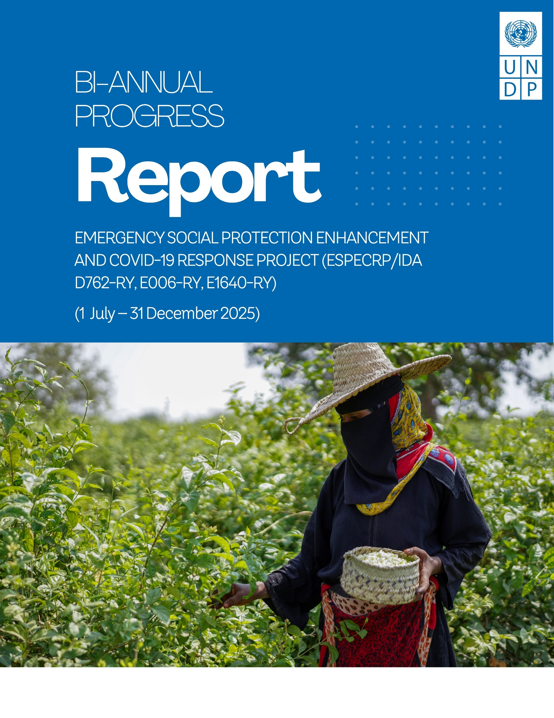

ABBREVIATIONS AND ACRONYMS
AF  BA  BC  CC  CBY  CFW  CFN  CHE  Houthi  ESAP  ESMF  ESPECRP  ESRM  FTO  GB  GBV  GRM  HH  IDA  IDPs  IFPRI  IRG  IPs  ISM  LTA  MIS  MFIs  OFAC  OHS  PDO  PWD  PF  PGM  PWP  RVM  SFD  MSME  SMED  SMEPS  SWF  TA  TPMA  UNDP  US$  WB  YER  YLG | Additional Financing  Business Association  Business Cooperative  Community Contracting  Central Bank of Yemen  Cash for Work  Cash for Nutrition  Community Health Educator  Houthi Movement  Environmental and Social Action Plan  Environmental and Social Management Framework  Emergency Social Protection Enhancement and COVID-19 Response Project  Environmental and Social Risk Management  Foreign Terrorist Organizations  Geobundling  Gender-Based Violence  Grievance Redress Mechanism  Household  International Development Association  Internally Displaced Persons  International Food Policy Research Institute  Internationally Recognized Government of Yemen  Implementing Partners  Implementation Support Mission  Long Term Agreement  Management Information System  Micro Finance Institutions  Office of Foreign Asset Control  Occupational Health and Safety  Project Development Objective  Person with Disability  Parent Fund  Portfolio Guarantee Model  Public Works Project  Remote Verification Mechanism  Social Fund for Development  Micro, Small and Medium Enterprise  Small and Micro Enterprises Development  Small and Medium Enterprise Promotion Services  Social Welfare Fund  Technical Assistance  Third Party Monitoring Agency  United Nations Development Programme  United States Dollar  The World Bank  Yemeni Riyal  Yemen Loan Guarantee

Contents
1. Executive Summary 5
2. Major Events 6
3. Progress of Project Development Objectives (PDOs) 7
4. Financial management and disbursement status 8
5. Progress by Subcomponent 9
5.1 Subcomponent 2.1 Cash for Nutrition (CFN): 9
5.2 Subcomponent 2.2 Cash for Work (CFW) 12
5.3 Subcomponent 2.3 Community Assets (CA) 15
5.4 Subcomponent 2.4a Increased Access to finance for MSMEs 18
5.5 Sub-component 2.4b Direct support to MSMEs and Business Associations in Critical Sectors 20
6. Component 2 Project Management, Monitoring, Evaluation and Capacity Building of National Institutions 23
7. Monitoring and Evaluation 26
8. Social and Environmental Risk Management 28
9. Communication & Visibility Plan 33
10. Key Actions/Activities for the Next Reporting Period (January to June 2026) 34
11. Risk Framework and Risk Mitigation Measures 35
12. ANNEXES: 37
Annex 1: Results Framework 37
Annex 2: Annual Progress (Expenses and Direct Beneficiaries) per Subcomponent 40
Annex 3: Subcomponent Intermediary RRF by Financing Agreement, as of 31 December 2025 41
Annex 4: Communication and Visibility Reference Links 42

Executive Summary

This biannual progress report summarizes implementation of the Yemen Emergency Social Protection Enhancement and COVID-19 Response Project (ESPECRP) during July - December 2025. The project is implemented by UNDP, in partnership with the Social Fund for Development (SFD), the Small and Micro Enterprise Promotion Service (SMEPS), and the Public Works Project (PWP).
The Project Development Objective (PDO) is to provide cash transfers, temporary employment, and improved access to basic services for food-insecure populations affected by conflict, COVID-19, and climate-related shocks, while strengthening national delivery systems. ESPECRP continues to apply the geobundling approach, integrating multi-sector interventions in high-need localities to enhance impact, resilience, and inclusion.
As of 31 December 2025, cumulative disbursement reached 72.9 percent of the US$232.9 million across three financing agreements. Despite a constrained operating environment, progress toward results remained broadly on track. 131,178 households received nutrition-sensitive cash assistance (exceeding targets by 23.2 percent), 123,391 individuals benefited from temporary employment (79.5 percent of the target), and approximately 1.3 million people gained improved access to basic services, including water, sanitation, and rural roads. The project supported 10,020 MSMEs, including 2,926 women-led enterprises, contributing to local economic recovery and food system resilience. Women, youth, and IDPs continued to be effectively mainstreamed across all components, and environmental and social safeguards were maintained through field supervision and third-party monitoring. The geobundling approach demonstrated strong added value by delivering more layered outcomes than single-intervention models, including increased employment, improved community assets, strengthened local economies, and enhanced social cohesion – particularly through expanded women’s participation in local governance structures.
Implementation during the reporting period, however, was significantly constrained by an increasingly complex operating context. Progress was adversely affected by a governance dispute within SFD and the associated suspension in disbursements by the World bank since mid-August 2025, as well as by security incidents involving the detention of UN personnel and raids on UN premises by the Houthis. Together, this led to a full pause of implementation in Houthi-controlled areas as of October 2025. These challenges were further compounded by the FTO designation, heightened political and security tensions, disruptions to banking and supply chains, delays in permit issuance by Houthi authorities, and prolonged environmental and social safeguard clearance processes.
Looking ahead, ESPECRP will prioritize accelerating implementation to meet end-of-project targets by end-2026. UNDP, in close coordination with the World Bank and implementing partners, will pursue targeted mitigation and acceleration measures, including expedited environmental and social clearances, streamlined financial processing, strengthened remote oversight and risk management arrangements, and selective reallocations across components as needed. These actions aim to safeguard development gains, sustain delivery momentum, and ensure continued progress toward the PDO in a highly constrained operating environment.

Major Events
Pause of Disbursements in Houthi-Controlled Areas: Following a significant deterioration in the operating environment, including raids on UN premises and the detention of UN personnel in September–October 2025, the World Bank, in consultation with UNDP, instructed a pause of project disbursements through SFD in 17 August 2025, and a pause of implementation in Houthi-controlled areas effective 21 October 2025. This measure, together with the earlier pause in disbursements through SFD and SMEPS since 17 August 2025 due to governance issues, had a significant impact on ESPECRP implementation. UNDP promptly operationalized the pause in accordance with agreed arrangements and progressed verification and settlement of eligible pre-pause commitments using conservative payment modalities, including direct payment and reimbursement. Based on jointly agreed exception criteria, UNDP submitted selected high-risk and time-critical activities for World Bank approval on a case by case basis, to ensure safe completion where prolonged suspension would pose contractual, environmental, social, or reputational risks. Accordingly, in January 2026, PWP received approval to finalize 34 subprojects in Houthi-controlled areas, with approximately US$1.0 million remaining for reimbursement. Activities implemented through SFD and SMEPS remain paused pending resolution of governance issues. Throughout the pause period, UNDP maintained third-party monitoring to ensure continued oversight and accountability. The TPM arrangement remains operational in southern areas. In northern areas, where implementation remains on pause, the TPM is awaiting permits from local authorities to access the limited number of subprojects approved under the agreed pause risk criteria. Should access not be granted, UNDP is exploring interim monitoring options, including an engineering TPM engaged under FSRRP and remote verification through the call center, and will consult with the World Bank on minimum monitoring requirements by end-March 2026.
SFD Leadership Dispute: A leadership dispute emerged within SFD in mid-August 2025 following the appointment of a new Managing Director by the Internationally Recognized Government and the suspension of the incumbent’s signatory authority. The dispute generated institutional uncertainty, disrupted financial processing across SFD branches, and adversely affected project delivery, including the suspension of ongoing subprojects, delays in staff payments, and increased beneficiary and staff complaints. In consultation with the World Bank, UNDP paused new financial advances to SFD and SMEPS and implemented risk-mitigation measures, including settling eligible pre-pause commitments through direct payment and reimbursement modalities. The World Bank, together with key SFD donors, led mediation efforts, resulting in agreement by Sana’a- and Aden-based leadership to establish a joint committee to finalize governance and decentralization arrangements, with a view to resuming operations in early 2026. In parallel, UNDP commissioned specialized legal advisory services, in agreement with the WB, to assess and mitigate risks related to the FTO designation and associated sanctions; the assignment is expected to conclude by end-February 2026.
Detention of UN Staff and Raids on UN Premises: Since early September 2025, the Houthis in Sana’a resumed the detention of national UN staff and conducted raids on UN premises, affecting multiple UN agencies, including UNDP. These developments significantly constrained operations in northern governorates by limiting staff movement, disrupting field monitoring, and suspending engagement with local authorities. The UN Country Team, under the leadership of the Resident and Humanitarian Coordinator and in coordination with UN Headquarters, continues high-level advocacy for the release of detained personnel. UNDP implemented enhanced security measures, limited field presence, and activated remote management and contingency protocols to safeguard staff safety and maintain critical operations, while sustaining essential service delivery in line with UN security and human rights principles.
Major Security and Political Developments – Aden: During the reporting period, the political and security situation in Aden experienced heightened volatility following an attempted expansion of influence by the Southern Transitional Council (STC) toward eastern governorates, which did not materialize. Swift political and security intervention by Saudi Arabia, including reinforcement of support to the Presidential Leadership Council, contributed to de-escalation and stabilization in Aden, preventing broader disruption. As a result, project implementation in southern areas was not materially affected and activities continued as planned. UNDP, in coordination with the World Bank, continues to monitor developments closely and apply enhanced risk management and contingency planning measures.

Progress of Project Development Objectives (PDOs)
1st PDO: Number of beneficiary households benefitting from cash for nutrition (CFN) reached 131,178 households (HHs) representing 123.1 percent of the total target, from the Social Welfare Fund (SWF) against a target of 9,300. Beneficiaries comprised 141,829 women, 127.1 percent of the target and 207,406 children reaching 135.6 percent of the target.
Under the 2nd PDO: Number of direct beneficiaries of wage employment, the project supported 123,391 direct workers, achieving 79.5 percent of the total target. This included 31,262 women workers; that’s 92.7 percent of the target of 33,710; and 10,355 Internally Displaced People (IDPs) representing 46.5 percent of the target of 22,281.
The progress under the 3rd PDO: over 1,311,536 people (116.8 percent of the total target), with improved access to basic services, with women constituting approximately 50 percent of the beneficiaries. Among these, 114,932 people (42.1 percent of the target), gained access to improved sanitation services, addressing water-borne diseases exacerbated by climate change.
In supporting MSMEs, the project achieved 100.2 percent of its target, benefiting 10,020 out of 10,009 planned MSMEs. This included 2,926 women-led MSMEs (105.4 percent of the target). Progress in women-led MSMEs improved due to targeted measures, such as expanding the scope to include all women income-generating activities, increasing loan coverage to encourage microfinance institutions to lend to more women, and enhancing engagement through awareness and follow-up efforts.
Table 1: ESPECRP PDO Progress as of 31 December 2025:
PDO Level Indicators | Total Target | Progress as of 31 Dec 2025 | %
PDO One: Provision of Cash Transfers  Number of households benefitting from the cash for nutrition | 106,500 | 131,178 | 123.2%
Number of beneficiary households (SWF) | 9,300 | 8,360 | 89.9%
Number of beneficiaries (women) | 111,600 | 141,829 | 127.1%
Number of beneficiaries (children) | 153,000 | 207,406 | 135.6%
PDO Two: Provision of temporary employment  The number of direct beneficiaries of wage employment | 155,208 | 123,391 | 79.5%
Number of beneficiaries (women) | 33,710 | 31,262 | 92.7%
Number of beneficiaries (IDPs) | 22,281 | 10,355 | 46.5%
PDO Three: Increased access to basic services and economic opportunities to vulnerable populations  Number of people with access to basic services | 1,122,880 | 1,311,536 | 116.8%
Of which, women % | 528,397 | 655,768 | 124.1%
Number of Micro, Small and Medium Enterprises (MSME) supported | 10,009 | 10,020 | 100.1%
Number of women led SMEs supported by the Project | 2,778 | 2,926 | 105.4%
People provided with access to improved sanitation services to reduce water-borne diseases exacerbated by climate change | 272,845 | 114,932 | 42.1%

Financial management and disbursement status

Since inception until the end of December 2025, UNDP has received US$ 202.10 million from the WB out of the total grant US$ 232.90 million under the three Grants (PF, AF and AF2). Of this amount, US$ 155.76 million was advanced to the project’s IPs, who in turn reported an expenditure of US$ 169.47 million, representing 72.77 percent of the total grant.

Table 2 below presents the financial status per grant, while the table in Annex 2 outlines the annual progress for each subcomponent.

Table 2: Financial Status as of 31 December 2025
ESPECRP | Total Grant, | Received From WB | Advance to IPs | Expenditures | Exp. % grant
PF (D762-RY) | 61,400,000.00 | 59,547,002.13 | 53,961,995.17 | 59,301,191.75 | 96.58%
AF (E006-RY) | 108,000,000.00 | 96,762,927.59 | 80,909,156.72 | 87,057,133.24 | 80.61%
AF2 (E164-RY) | 63,500,000.00 | 45,793,080.00 | 20,898,205.11 | 23,113,546.02 | 36.40%
TOTAL | 232,900,000.00 | 202,103,009.72 | 155,769,357.00 | 169,471,871.01 | 72.77%

Under the original financing (PF), UNDP received US$ 59.55 million out of US$ 61.4 million, and the remaining balance to be requested from the WB is US$ 0.39 million. The actual expenditure reported by UNDP and IPs amounted to US$ 59,30 million at the end of December 2025, representing 96.58 percent of the total grant amount.

Table 3: Financial Status of ESPECRP PF as 31 December 2025
ESPECRP PF (D762) | Total grant | Advanced to IPs | Expenditures | % Exp/grant
Component 2 | 55,400,000.00 | 53,999,358.65 | 53,961,995.17 | 97.40%
2.1 Cash for Nutrition (SFD) | 14,782,799.31 | 13,869,121.15 | 13,869,121.15 | 93.82%
2.2 Cash for Work (SFD) | 3,339,000.02 | 3,339,000.02 | 3,339,000.02 | 100.00%
SFD Management 2.1, 2.2, 2.4(a) | 15,700,000.00 | 15,329,842.26 | 15,292,478.78 | 97.40%
2.3 Community Assets (PWP) | 2,100,000.00 | 2,100,000.00 | 2,100,000.00 | 100.00%
2.4(a)(i) YLG Subgrant (SFD/YLG) | 259,991.26 | 259,991.26 | 259,991.26 | 100.00%
2.4(a)(ii) VSLAs (SFD/SMED) | 76,000.00 | 76,000.00 | 76,000.00 | 100.00%
2.4(a)(iii) MFIs Support (SFD/SMED) | 4,500,000.00 | 4,383,194.55 | 4,383,194.55 | 97.40%
2.4(b) MSMEs (SMEPS) | 14,642,209.41 | 14,642,209.41 | 14,642,209.41 | 100.00%
Component 3: UNDP Project Management | 6,000,000.00 | 0.00 | 5,339,196.58 | 88.99%
TOTAL | 61,400,000.00 | 53,999,358.65 | 59,301,191.75 | 96.58%

Under the Additional Financing (AF) UNDP received US$ 96.76 million - 89.59 percent of AF allocation. The expenditure reported by UNDP and IPs reached US$ 87.05 million - 80.61 percent.
Table 4: Financial Status of ESPECRP AF as 31 December 2025
ESPECRP AF (E006) | Total grant | Advance to IPs | Expenditures | % Exp/grant
Component 2 | 99,200,000.00 | 80,909,156.72 | 79,849,819.46 | 80.49%
2.1 Cash for Nutrition | 25,796,398.61 | 24,118,869.03 | 24,070,817.72 | 93.31%
2.2 Cash for Work | 25,103,036.67 | 21,395,275.66 | 20,386,608.59 | 81.21%
2.4 (a)(i) YLG Subgrant | 2,000,000.00 | 2,000,000.00 | 2,000,000.00 | 100.00%
2.4 (a)(ii) VSLAs | 2,730,000.00 | 2,730,000.00 | 2,569,202.57 | 94.11%
SFD Management 2.1, 2.2, 2.4 (a)(i) | 8,970,564.72 | 5,185,501.93 | 6,354,966.43 | 70.84%
2.3 Community Assets (PWP) | 27,600,000.00 | 19,907,217.82 | 18,943,152.43 | 68.63%
2.4 (b) MSMEs (SMEPS) | 7,000,000.00 | 5,572,292.28 | 5,525,071.72 | 78.93%
Component 3: UNDP Project Management | 8,800,000.00 | 0 | 7,207,313.78 | 81.90%
TOTAL | 108,000,000.00 | 80,909,156.72 | 87,057,133.24 | 80.61%

Regarding the Second Additional Financing (AF2), UNDP received US$ 45.79 million - 72.11 percent of AF2 allocation. The expenditure reported by UNDP and IPs is US$ 23.11 million (36.40 percent).
Table 5: Financial Status of ESPECRP AF2 as 31 December 2025
ESPECRP AF2 (E164) | Total Grant | Advanced to IPs | Expenditures | % Exp/grant
Component # 2 | 55,900,000.00 | 20,898,205.11 | 20,622,462.73 | 36.89%
2.1 Cash for Nutrition | 17,005,000.00 | 9,603,049.14 | 9,492,689.51 | 55.82%
2.2 Cash for Work | 13,425,000.00 | 2,607,584.29 | 2,520,124.04 | 18.77%
Geobundling Community Mobilization | 900,000.00 | 900,000.00 | 721,307.60 | 80.15%
2.4 (a)(i) YLG Subgrant | 1,000,000.00 | 1,000,000.00 | 1,000,000.00 | 100.00%
2.4 (a)(ii) VSLAs | 1,350,000.00 | 757,736.71 | 749,033.70 | 55.48%
SFD Management 2.1, 2.2, 2.4 (a)(i) | 3,720,000.00 | 1,977,274.15 | 2,252,129.81 | 60.54%
2.3 Community Assets (PWP) | 15,000,000.00 | 3,280,503.33 | 3,280,503.33 | 21.87%
2.4 (b) MSMEs (SMEPS) | 3,500,000.00 | 772,057.49 | 606,674.74 | 17.33%
Component 3: UNDP Project Management | 7,600,000.00 | 0 | 2,494,625.71 | 32.78%
TOTAL | 63,500,000.00 | 20,898,205.11 | 23,113,546.02 | 36.40%

Progress by Subcomponent

Subcomponent 2.1 Cash for Nutrition (CFN):
The CFN subcomponent of ESPECRP has proven essential in improving nutrition and reducing food insecurity among vulnerable women and children. Cumulatively, from the project’s inception through 31 December 2025, around 131,178 households were provided with cash assistance along with nutrition and health awareness sessions, achieving 123.2 percent of the overall target in 45 target subdistricts across 19 governorates. The assistance reached 141,829 women (127.1 percent of the target) and 207,240 children (135.5 percent of the target), nearly half of whom were girls. Of these households, 8,360 (89.9 percent of the target) are beneficiaries from the Social Welfare Fund (SWF) who are considered among the poorest of the poor. Notably, among the women beneficiaries, 6,062 are women-headed households, 5,184 are IDPs, and 10,161 are women with children who have disabilities. Therefore, CFN has not only addressed its main objective of reducing malnutrition but also contributed to addressing intersectional vulnerabilities and enhancing social inclusion.
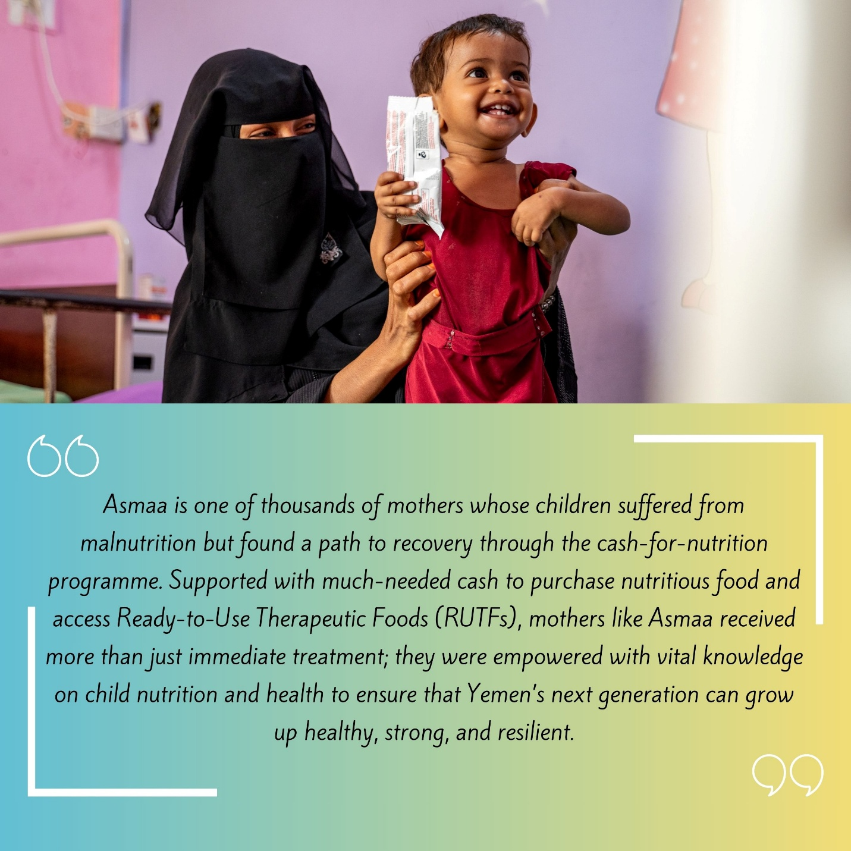
The project also created meaningful livelihood opportunities for young women through the training and short-term employment of 4,901 Community Health Educators (CHEs) – 125 percent of the target. These CHEs generated approximately 910,757 workdays, enhancing household income and women’s agency. They conducted 841,476 home visits and facilitated 47,843 group awareness sessions on topics such as reproductive health, personal hygiene, breastfeeding, and prevention of waterborne diseases, thereby contributing to long-term behavior change and improved health outcomes in underserved communities. Using Mid-Upper Arm Circumference (MUAC) screening, CHEs identified 34,257 malnutrition cases (12,014 children and 22,243 pregnant and lactating women), of which 25,901 cases (75.6 percent) have fully recovered following referral and treatment at health facilities, demonstrating the effectiveness of the subcomponent identification and referral model in preventing severe malnutrition.

Table 6: CFN Subcomponent Progress Status cumulatively until 31 December 2025
Governorate | District | Women Educators |  | Women received CT | Children
Governorate | District | No. | Workdays | Women received CT | Boys | Girls | Total
PF
Hadhramout | Broom Mayfa'a | 100 | 17336 | 2,709 | 2,083 | 1,939 | 4,022
Al-Hudaydah | AL-Hujailah | 69 | 14,036 | 2,030 | 1,532 | 1,421 | 2,953
Raymah | Belad Atta'am | 191 | 33,682 | 5,837 | 4,652 | 4,520 | 9,172
Lahj | Tuban | 401 | 76,142 | 21,568 | 14,993 | 14,283 | 29,276
Dhamar | Jabal Asharq | 326 | 59,378 | 12,154 | 9,180 | 9,110 | 18,290
Sub-total |  | 1,087 | 200,574 | 44,298 | 32,440 | 31,273 | 63,713
AF
AL-Mahwit | Bani Sa'd | 367 | 67,432 | 11,662 | 9,880 | 9,359 | 19,239
Dhamar | Al-Manar | 303 | 67,920 | 9,522 | 7,491 | 6,969 | 14,460
Hadhramaut | Ghayl Bawazir | 122 | 24,447 | 3,066 | 2,206 | 1,962 | 4,168
Al-Bayda | Sabah | 102 | 20,742 | 2,811 | 2,103 | 2,056 | 4,159
Raymah | Mazhar | 89 | 17,402 | 2,311 | 1,775 | 1,685 | 3,460
Taiz | Al Misrakh | 126 | 29,553 | 3,340 | 2,374 | 2,267 | 4,641
Ibb | Far' Al Odayn | 101 | 16,297 | 2,403 | 1,904 | 1,752 | 3,656
Hajjah | Ku'aydinah | 79 | 16,353 | 1,977 | 1,662 | 1,546 | 3,208
Shabwah | Bayhan | 97 | 18,495 | 2,396 | 1,616 | 1,534 | 3,150
Al-Hudaydah | Al Zuhrah | 142 | 33,728 | 5,072 | 4,118 | 3,783 | 7,901
Al-Jawf | Kharb Almarashi | 77 | 12,598 | 1,527 | 1,277 | 1,231 | 2,508
Marib | Ma'rib Alwadi | 118 | 17,609 | 2,350 | 1,920 | 1,790 | 3,710
Amran | Jabal Iyal Yazid | 111 | 23,143 | 3,418 | 2,525 | 2,258 | 4,783
Lahj | Tur AlBaha | 174 | 35,180 | 4,642 | 3,028 | 2,938 | 5,966
Abyan | Khanfar | 177 | 34,965 | 4,300 | 3,177 | 2,915 | 6,092
Sana'a | Hamdan | 327 | 38,895 | 8,506 | 5,901 | 5,436 | 11,337
Al-Dhalea | Al-Husha | 82 | 8,780 | 1,261 | 868 | 823 | 1,691
Sub-total |  | 2,536 | 2,594 | 483,539 | 70,564 | 104,129 | 53,825
AF2
Hadhramaut | Ash Shihr | 68 | 13,875 | 1,429 | 945 | 840 | 1,785
Hajjah | Al Maghrabah | 146 | 25,752 | 3,551 | 3,194 | 2,927 | 6,121
Taiz | Al Mawasit | 193 | 37,747 | 3,864 | 2,562 | 2,449 | 5,011
Ibb | Hazm Al Udayn | 67 | 14,388 | 1,017 | 891 | 868 | 1,759
Amran | Kharif | 73 | 15,788 | 1,691 | 1,271 | 1,095 | 2,366
Shabwah | Maif'ah | 40 | 9,131 | 582 | 428 | 430 | 858
Al-Hudaydah | Bajil | 75 | 12,929 | 1,434 | 1,081 | 945 | 2,026
Raymah | Al Jafariyah | 183 | 33,137 | 4,594 | 3,643 | 3,357 | 7,000
Al-Jawf | Bart Al Anan | 53 | 7,324 | 1,633 | 1,278 | 1,154 | 2,432
Marib | Jabal Murad | 35 | 6,598 | 518 | 373 | 363 | 736
Dhamar | Dawran Aness | 82 | 17,073 | 2,049 | 1,505 | 1,315 | 2,820
Al-Bayda | Al Malagim | 81 | 17,033 | 1,956 | 1,518 | 1,530 | 3,048
Lahj | Al Had | 19 | 3,943 | 606 | 405 | 403 | 808
Al-Dhalea | Damt | 105 | 11,926 | 1,913 | 1,374 | 1,254 | 2,628
TOTAL |  | 2,594 | 483,539 | 70,564 | 53,825 | 50,304 | 104,129
Grand TOTAL |  | 4,901 | 910,757 | 141,699 | 106,733 | 100,507 | 207,240

The CFN program faced significant challenges during the reporting period, primarily due to the suspension of funding following SFD’s internal governance crisis and the donor-mandated pause in northern areas. The suspension interrupted monthly cash transfers during active nutrition cycles for pregnant and lactating women, adversely affecting food security and nutrition outcomes and undermining beneficiary trust. It also disrupted referral pathways to health and nutrition services and delayed planned behavior change, follow-up, and monitoring activities, posing risks to the effectiveness and sustainability of nutrition outcomes.

In addition, payment delays reduced the real value of assistance, increased reputational risks, and created administrative challenges. While SFD maintained coordination with health facilities, preserved referral records, and continued essential monitoring and remote follow-up to mitigate impacts, the prolonged duration of the suspension limited the effectiveness of these measures. UNDP and SFD will develop and implement an acceleration plan once activities resume to restore service continuity and recover momentum.

Photo credit: UNDP Yemen

Subcomponent 2.2 Cash for Work (CFW)
Workers setting up the foundation of water tank tower as a part of the geo-bundling interventions in Al-Majhafa, Lahj. | Photo Credit: @UNDP Yemen / 2024
Under the CFW subcomponent, the ESPECRP project has made significant contributions toward supporting vulnerable populations in conflict-affected areas of Yemen. By combining short-term income opportunities with the development of essential community assets, the program has helped households cope with food insecurity, enhanced climate resilience, and restored critical local services. As of December 2025, a total of 278 CFW subprojects were identified across 174 subdistricts in 120 districts spanning all 22 governorates, with an estimated cost of US$ 42.04 million, representing 98 percent of the total CFW allocation under the three project funds (PF, AF, AF2). Of these, 163 subprojects (US$ 22.7 million) have been completed, 104 (US$ 17.0 million) are under implementation, and 6 (US$ 1.4 million) are in preparatory stages. Only four subprojects were cancelled, all previously reported.

CFW interventions pursues an inclusive and localized approach, ensuring effective resource utilization and maximized community benefits. Implemented subprojects have responded to pressing community needs such as agricultural land rehabilitation, irrigation canal repair, rainwater harvesting, rural road construction, home gardens, and sanitation infrastructure.
Table 7: Status of CFW Subprojects as of 31 December 2025

 | Completed |  | Cancelled |  | Ongoing |  | In Preparation |  | Total Subprojects
Intervention Type | # | US$ | # | US$ | # | US$ | # | US$ | # | US$
CFW – Agriculture | 27 | 4,026,387 |  |  | 27 | 3,837,073 | 1 | 125,000 | 55 | 7,988,460
CFW - Diversified | 84 | 12,232,994 | 2 | 362,107 | 43 | 7,494,991 | 2 | 270,272 | 131 | 20,360,364
CFW – Roads | 42 | 5,159,996 | 1 | 198,000 | 34 | 5,558,069 | 3 | 989,672 | 80 | 11,905,737
CFW – WASH | 10 | 1,320,110 | 1 | 331,000 | 1 | 132,026 |  |  | 12 | 1,783,136
Grand Total | 163 | 22,739,487 | 4 | 891,107 | 105 | 17,022,159 | 6 | 1,384,944 | 278 | 42,037,697

To date, 58,418 direct workers (75.2 percent of the project target) have accessed short-term wage employment, enabling them to purchase essential items, such as food and medicine, while improving their households’ well-being. Women comprised 31.9 percent, youth 53.1 percent, and IDPs 10.8 percent of total CFW workers. The program designed CFW tasks that were accessible and meaningful for women, including home gardening, tree planting, water carrying for construction and participation in training and awareness sessions, allowing them to work flexibly and safely. Women received individual payment cards for direct and transparent compensation and played active roles in project planning and decision-making, including through subproject committees—strengthening their leadership and voice in community development. Additionally, around 1,125 Persons with Disabilities (PWD) (20 percent women) were engaged in CFW thus far, in activities including construction of latrines, painting, terraces rehabilitation, life skills training, and awareness sessions, among others.

In addition to income support, CFW contributed to both skills’ development and longer-term economic resilience. Over 5,870 unskilled and semi-skilled workers received on-the-job training in areas such as masonry, stone cutting, cement work, plumbing, blacksmithing, and asset maintenance. These skills not only supported the delivery of high-quality community assets but also improved participants’ future employment beyond the project’s duration. The table below provides disaggregated CFW workers per governorate.

Table 8: CFW Disaggregated Workers and Workdays per Governorate as 31 December 2025
GOVERNORATE | No. of SUBPROJECTS | NO. OF WORKERS |  |  |  | NO. OF WORKDAYS
GOVERNORATE | No. of SUBPROJECTS | TOTAL | WOMEN | IDPS/RETURNEES | YOUTH | NO. OF WORKDAYS
Abyan | 9 | 1,311 | 287 | 27 | 568 | 60,802
Aden | 4 | 625 | 168 | 173 | 368 | 14,585
Al-Bayda | 10 | 1,963 | 788 | 43 | 1,203 | 57,695
Al-Dhalea | 13 | 2,181 | 484 | 266 | 1,096 | 78,035
Al-Jawf | 8 | 1,548 | 313 | 151 | 807 | 62,966
Al-Mahrah | 3 | 604 | 258 | 103 | 370 | 31,410
AL-Mahwit | 9 | 1,598 | 165 | 107 | 827 | 66,487
Amran | 15 | 2,302 | 164 | 41 | 1,240 | 98,258
Dhamar | 17 | 4,384 | 1,511 | 23 | 2,482 | 143,660
Hadhramout | 11 | 2,235 | 376 | 9 | 1,025 | 103,123
Hajjah | 25 | 7,886 | 2,920 | 1,462 | 4,380 | 221,679
Al-Hudaydah | 29 | 8,390 | 4,060 | 118 | 4,247 | 314,673
Ibb | 25 | 5,531 | 2,592 | 461 | 2,962 | 191,942
Lahj | 9 | 1,583 | 213 | 24 | 730 | 62,233
Marib | 13 | 2,105 | 687 | 824 | 1,201 | 74,422
Raymah | 10 | 1,722 | 391 | 72 | 744 | 75,048
Sa’adah | 11 | 1,800 | 176 | 284 | 885 | 78,614
Sana’a | 12 | 2,446 | 242 | 332 | 1,332 | 75,081
Sana’a Capital | 5 | 1,119 | 150 | 445 | 762 | 22,369
Shabwah | 8 | 1,964 | 508 | 63 | 1,178 | 54,780
Socotra | 4 | 382 | 57 | - | 164 | 33,542
Taiz | 28 | 4,739 | 2,037 | 1,279 | 2,372 | 147,310
TOTAL | 278 | 58,418 | 18,547 | 6,307 | 30,943 | 2,068,713

The dual benefit of income and asset creation is evident in the tangible results. The project constructed 41,122 cubic meters of rainwater harvesting systems (89.3 percent of target), reducing water scarcity and easing the burden on women and children. Around 4,357 hectares of agricultural land and terraces (175.8 percent) were rehabilitated and irrigated, boosting food production and strengthening climate resilience. A total of 262 kilometers of rural feeder roads (125.9 percent) were paved, improving mobility, market access, and service delivery in previously isolated communities.

CFW also supported improved nutrition, health and shelter. 1,845 home vegetable gardens were established, increasing household food diversity and consumption of fresh produce. 7,338 latrines with cesspits improved sanitation coverage and reduced disease risks. To protect vulnerable families from climate shocks, 314 shelters and 307 flood-resilient houses were constructed. Collectively, the completed CFW subprojects improved access to critical services for an estimated 470,901 people (104.0 percent of the target), approximately half of whom are women.

To promote sustained self-reliance, particularly among women, 1,700 households (approximately 27 percent women) were supported in acquiring locally appropriate productive assets—ranging from livestock and beehives to sewing machines and motorcycles. In addition, beneficiaries received life skills and entrepreneurship training that enabled them to produce and market items such as incense, perfumes, dairy products, pickles, and handicrafts—laying the groundwork for sustainable income-generation and long-term economic empowerment.

Table 9: CFW HH, Workers, and workdays per sector and category as of 31 December 2025
Intervention | # | NO. OF HH | NO. OF WORKERS |  |  |  | NO. OF WORKDAYS
Intervention | # | NO. OF HH | TOTAL | Women | IDP | YOUTH | TOTAL | Women | IDP | YOUTH
Agriculture | 55 | 10,187 | 14,061 | 34% | 51% | 7% | 518,336 | 25% | 50% | 6%
Diversified | 131 | 22,845 | 31,755 | 38% | 52% | 12% | 1,157,430 | 31% | 49% | 10%
Roads | 80 | 9,935 | 10,163 | 7% | 58% | 14% | 293,423 | 4% | 58% | 12%
WASH | 12 | 1,664 | 2,439 | 38% | 51% | 8% | 99,524 | 24% | 48% | 7%
TOTAL | 278 | 44,631 | 58,418 | 32% | 53% | 11% | 2,068,713 | 25% | 51% | 9%
During the reporting period, the suspension of CFW activities due to SFD’s issue following by the WB’s imposed pause in the North significantly affected household incomes and program delivery. Six approved projects and 128 ongoing projects were halted, resulting in more than 20,000 workers losing access to planned short-term employment and wage income.
The suspension also delayed completion and maintenance of community assets, increasing the risk of deterioration. These disruptions contributed to community frustration and emerging reputational risks for SFD and the project stakeholders, during a time of heightened food insecurity.

Subcomponent 2.3 Community Assets (CA)

Since its inception, the PWP subcomponent has achieved tangible results in improving access to essential services and enhancing the resilience of vulnerable and food-insecure communities. By the end of December 2025, a total of 390 subprojects had been approved across 229 subdistricts in 147 districts, covering all 22 governorates of Yemen, with an estimated total cost of US$ 38.9 million, representing 89 percent of the overall civil works allocation. Of these, 282 subprojects (US$ 24.9 million) were completed, 58 (US$ 6.8 million) are under implementation, and 50 subprojects (US$ 7.1 million) are finalizing technical and environmental and social risk assessments.

These community-prioritized interventions have addressed critical development needs including the construction of communal rainwater harvesting reservoirs, rehabilitation of water supply and sanitation networks, paving rural roads, and protection of agricultural lands resulting in improved living conditions, food security, and climate adaptation in conflict-affected areas.

Table 10: Status of Subprojects under Subcomponent 2.2 (PWP) as of 31 December 2025
Subprojects | In Preparation |  | Under implementation |  | Completed |  | TOTAL
Sector of Intervention | No. | US$ | No. | US$ | No. | US$ | No. | US$
Agri Land Protection & irrigation | 29 | 4,297,165 | 20 | 1,974,352 | 84 | 7,325,619 | 133 | 13,597,136
Rainwater Harvesting | 6 | 916,448 | 18 | 1,959,382 | 53 | 4,489,900 | 77 | 7,365,730
Stone Paving Rural Roads | 14 | 1,717,615 | 18 | 2,716,654 | 94 | 8,752,365 | 126 | 13,186,634
Water Supply Schemes | 1 | 190,675 | 2 | 181,176 | 44 | 3,975,423 | 47 | 4,347,274
Sanitation | 0 | - | 0 | 0 | 7 | 401,226 | 7 | 401,226
Total | 50 | 7,121,903 | 58 | 6,831,564 | 282 | 24,944,533 | 390 | 38,898,000

A total of 70 subprojects (PF:18, AF: 38 and AF2: 14) were implemented using the Community Contracting (CC) modality, valued at US$ 6.4 million, covering 34 agricultural land protection and irrigation, 21 rural road pavements, and 14 rainwater harvesting and 1 water schemes. To date, 47 CC subprojects have been completed, and 23 are under implementation. The CC approach not only accelerated delivery and enhanced local ownership but also built long-term community capacity.
a rugged, steep road was paved through PWP’s community contracting in Al-Sarrah, Al-Odein, Ibb. | Photo Credit: @UNDP Yemen / 2023

Table 11: Status of Community Contracting Subprojects (PWP) as of 31 December 2025
Subprojects | In Preparation |  | Under implementation |  | Completed |  | TOTAL
Sector of Intervention | No. | US$ | No. | US$ | No | US$ | No | US$
Agri Land Protection/irrigation | 0 | 0 | 15 | 1,508,807 | 19 | 1,535,917 | 34 | 3,044,723
Rainwater Harvesting | 0 | 0 | 3 | 579,556 | 11 | 1,506,625 | 14 | 2,086,181
Stone Paving Rural Roads | 0 | 0 | 4 | 446,270 | 17 | 762,249 | 21 | 1,208,519
Water Supply Schemes | 0 | 0 | 1 | 86,200 | - | - | 1 | 86,200
Total | - | - | 23 | 2,620,832 | 47 | 3,804,791 | 70 | 6,425,623

To date, the subcomponent has provided short-term employment to 28,844 direct workers (55.5 percent of the target), including 844 women (38.9 percent of the women’s target), and 3,533 IDPs (12.3 percent), generating over 655,065 workdays and indirectly benefiting 350,508 household members. These job opportunities provided immediate income relief, while supporting longer-term recovery and resilience.
Table 12: CA Disaggregated Workers and Workdays per Governorate
GOVERNORATE | No. of SUBPROJECTS | NO. OF WORKERS |  |  | NO. OF WORKDAYS
GOVERNORATE | No. of SUBPROJECTS | TOTAL | WOMEN | IDPS/RETURNEES | NO. OF WORKDAYS
Abyan | 13 | 609 | 0 | 43 | 16,874
Aden | 9 | 519 | 6 | 210 | 15,252
Al Baidha | 12 | 854 | 20 | 119 | 25,465
Ad-Dhale’e | 13 | 1,054 | 65 | 65 | 18,318
Al-Jawf | 25 | 2,100 | 13 | 35 | 45,639
Al Mahrah | 16 | 1,188 | 6 | 209 | 21,439
Al Mahweet | 9 | 747 | 8 | 58 | 15,376
Amran | 13 | 947 | 11 | 93 | 24,302
Dhamar | 15 | 1,423 | 72 | 130 | 30,690
Hadhramout | 15 | 1,507 | 8 | 261 | 35,660
Hajjah | 21 | 1,888 | 69 | 74 | 43,377
Hodeidah | 16 | 947 | 19 | 94 | 21,392
Ibb | 27 | 2,339 | 24 | 270 | 60,293
Lahj | 28 | 1,844 | 88 | 104 | 38,387
Marib | 16 | 701 | 22 | 12 | 17,892
Raymah | 23 | 1,696 | 23 | 575 | 45,939
Sa’adah | 10 | 1,276 | 55 | 129 | 26,895
Sana’a | 19 | 1,610 | 40 | 503 | 32,892
Sana’a Capital | 17 | 779 | 49 | 114 | 22,612
Shabwah | 23 | 1,477 | 89 | 106 | 22,589
Socotra | 12 | 662 | 30 | 48 | 12,782
Taiz | 38 | 2,677 | 127 | 281 | 61,000
TOTAL | 390 | 28,844 | 844 | 3,533 | 655,065
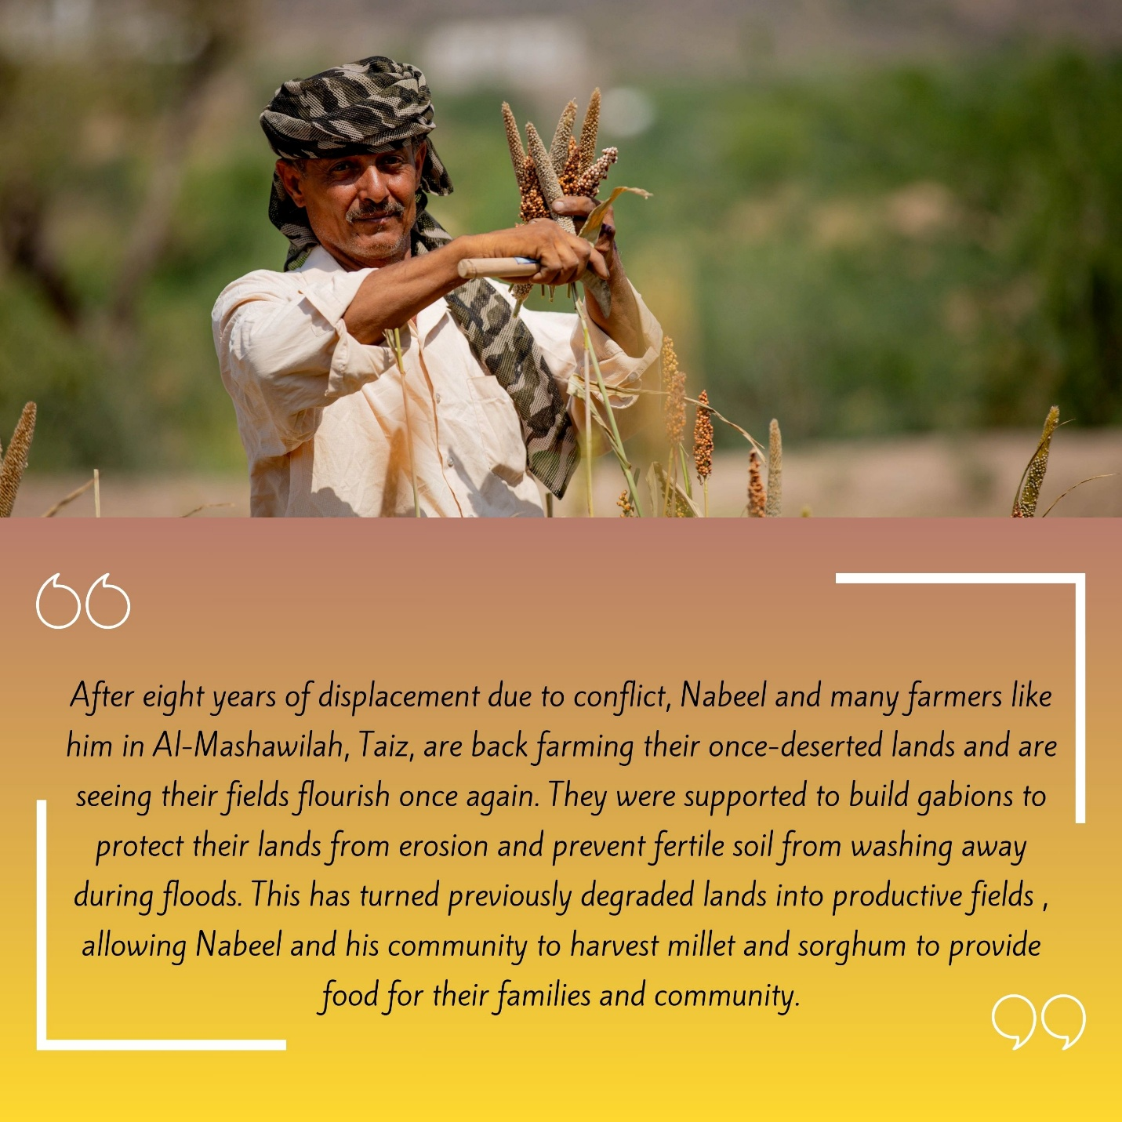
The infrastructure delivered under the subcomponent has directly enhanced access to essential services and contributed to climate resilience. To date, 191,204 cubic meters of rainwater harvesting capacity (129.7 percent of target) have been constructed, ensuring safer and more reliable access to clean water. Additionally, 279,861 meters of water supply and 1,689 meters of sanitation networks have been repaired, with four new public latrines constructed—reducing waterborne disease risks and strengthening sustainable water use for both domestic and agricultural purposes. The subcomponent has also advanced climate-resilient food production and disaster mitigation, rehabilitating and protecting 5,676 hectares of agricultural land (113.2 percent of the target), while the improvement of 125 kilometers of rural roads (76.7 percent) significantly reduced transport costs and isolation in remote areas. Associated retaining walls and tree planting further helped prevent landslides and soil erosion.

The combination of physical infrastructure and community awareness on climate change enhanced co-benefits and sustainability. Overall, completed subprojects have improved access to key services for 840,635 people, exceeding the overall target by 25 percent, with an equitable reach across gender.
Table 13: Total Job Opportunities under CA as of 31 December 2025
Sector | Workdays generated |  |  | Direct Beneficiaries of wages
Sector | Total | % Host Community | % IDP's | Total | % Host Community | % IDP's
Water harvesting tanks | 143,522 | 88% | 13% | 6,553 | 88% | 13%
Land Protection & Irrigation | 277,675 | 81% | 19% | 12,861 | 76% | 25%
Rural roads pavement | 373,900 | 89% | 11% | 16,126 | 92% | 8%
Sanitation & Water supply | 143,957 | 89% | 12% | 6,222 | 86% | 14%
Total | 939,054 | 86.50% | 13.50% | 41,762 | 85.25% | 14.75%
The PWP’s earlier reported project amount (US$ 1.02 million) frozen at Yemen Kuwait Bank (YKB) due to sanctions has been covered by UNDP, enabling PWP to continue the delivery towards reaching the project targets. Additionally, the aging PWP vehicle fleet poses safety risks and high maintenance costs. UNDP and the WB have prepared the case and risk measures for purchasing used clean cars for the branches in high need, which has been pending a final decision from WB’s compliance and management.
Furthermore, the pause of implementation in the North has caused considerable delay in the progress given the concentration of ongoing subprojects there. A total of 46 subprojects (US$5.86 million) were affected, including 14 roads, 13 water schemes, and 7 agricultural protection and irrigation interventions. The pause has also increased the social, environmental and financial risks to PWP and the communities due to the abrupt cut of implementation. Following a risk-based review against agreed criteria, the World Bank concurred with UNDP’s assessment to complete 34 subprojects (estimated at US$1 million).

Subcomponent 2.4: Economic Opportunities and Food Market Resilience
Photo credit: UNDP Yemen

Subcomponent 2.4a Increased Access to finance for MSMEs

Yemen Loan Guarantee program (YLG):
Through the implementation of the Portfolio Guarantee Model (PGM), ESPECRP – via the Yemen Loan Guarantee (YLG) – significantly enhanced MSMEs' access to finance by mitigating credit risks for financial institutions and MFIs. Contracts were signed with all six targeted MFIs, resulting in guaranteed loans to 5,353 MSMEs (142.6 percent of target) of which 21.4 percent are women-led MSMEs, creating or sustaining around 8,682 jobs (with 24.2 percent females) across diverse productive sectors. Notably, 44.8 percent of supported businesses were in rural areas, and 50.4 percent youth led.
The percentage of women has improved significantly under AF2 since the WB’s approval of opening the sectors to all women-led businesses rather than food sectors. The participation is expected to increase even more should the risk coverage increase from 70 percent to 90 percent for women-led businesses. The total value of guaranteed loans reached US$ 15.3 million, demonstrating tangible progress in promoting inclusive economic recovery and livelihood.

Table 14: Number of guarantees issued and sum of guaranteed amount as of 31 December 2025
Key indicator | Alamal MF Bank | Azal MFI | Alitihad MFI | Alkuraimi MF Bank | Althadhamon MFI | Nama MFI | Total
# of Guarantees | 89 | 2,065 | 359 | 2,346 | 199 | 295 | 5,353

The supported MSMEs included a variety of productive and economic sectors and different purposes as in the following table:

Table 15: Cumulative number of clients by sector and by loan purpose, as of 31 December 2025

Sector | #Clients | % | Loan Guarantee |  | Loan Purpose | #Clients | % | Loan Guarantee
Agricultural | 1,369 | 25.6% | $5,329,730 |  | Assets for Business | 581 | 10.9% | $2,087,371
Livestock | 922 | 17.2% | $1,307,273 |  | Inventory | 2,576 | 48.1% | $7,085,961
Commercial | 2,552 | 47.7% | $7,251,905 |  | Green Houses | 72 | 1.4% | $165,885
Fish | 34 | 0.6% | $50,522 |  | Solar Energy | 177 | 3.3% | $1,653,180
Industry | 212 | 4.0% | $495,613 |  | Fuel for Energy | 250 | 4.7% | $808,935
Service | 264 | 4.9% | $861,207 |  | Raw Materials | 842 | 15.7% | $2,186,184
 |  |  |  |  | Livestock | 745 | 14.4% | $1,308,733
Total | 5,353 |  | $15,296,250 |  | Total | 5,353 |  | $15,296,250

Key lessons learned indicate that the portfolio guarantee model should be implemented over a minimum period of three years to ensure it achieves its intended objectives, with dedicated attention to women-led activities through tailored design features. An independent team should be assigned to manage the product, alongside continuous learning and integration of best practices to strengthen workflows and improve outcomes over time.
A key challenge for YLG was the difficulty they faced to access their balance held at YKB due to U.S. sanctions. Although over half of the funds have been successfully withdrawn under a rescheduled arrangement, the remaining (US$ 480,503 out of US$ 1.07 million) is still frozen after YKB’s declared inability to continue. YLG is in continuous communication with YKB to release the amount, and UNDP has communicated with the Central Bank of Yemen in Aden in attempt to find a solution in releasing the stuck funds, but the situation remains complicated thus far.

Village Saving and Loan Associations (VSLAs):
VSLAs strengthen financial empowerment by promoting savings, improving access to affordable credit, and building practical financial literacy, enabling members to diversify incomes and enhance household resilience. Beyond economic gains, VSLAs foster collective action, community development, and personal growth by building entrepreneurial skills, leadership, problem-solving capacity, and self-confidence, allowing members—especially women—to play a more active role in their communities.
Cumulatively, by the end of December 2025, the project formed 716 VSLAs (100.1 percent of the total target) of which 51 percent are women VSLAs. Through community mobilization and capacity-building initiatives, the project has equipped 17,381 VSLA members (of whom 8,790 are women) with VSLA-related materials, including cash boxes and stationery, as well as with training in savings, lending, financial literacy and entrepreneurship. To enhance financial skills and ensure effective record-keeping of the VSLAs, 8,490 (49 percent women) of the VSLA members received a five-day training on financial accounting.
In addition, the project provided 4,059 (56 percent women) with vocational skills training. All these efforts have strengthened members’ ability to manage their finances, operate SMEs effectively, and improve their livelihoods. Cumulatively, 1,666 MSMEs were created and received loans (of which 56 percent for women) , with total saving amounting to around YER 627.2 million, supporting diverse economic activities and creating or sustaining 3,332 job opportunities (56 percent women).

Table 16: Loans Disbursed by VSLAs
Business Type/ Sector | N. of loans disbursed |  |  | %
Business Type/ Sector | Men | Women | Total | %
Beekeeping, Livestock, and Agricultural | 327 | 340 | 667 | 40
Commercial | 180 | 291 | 471 | 28
Handcraft/Industry | 46 | 236 | 282 | 17
Service | 172 | 74 | 246 | 15
Total | 725 | 941 | 1,666 | 100%

VSLA savings, while valuable, remain insufficient to meet the full demand for business loans, limiting members’ ability to start or scale enterprises; linking VSLAs with MFIs and providing grants or revolving funds is needed to expand SME opportunities. In addition, limited literacy, particularly among women, constrains effective participation and financial management, while access to vocational training remains limited to a small number of members, highlighting the need to scale up skills development to support sustainable livelihoods.

Sub-component 2.4b Direct support to MSMEs and Business Associations in Critical Sectors
one of SMEPS’ consultants explains to some women livestock breeders proper ways to feed their livestock. | Photo Credit: @UNDP Yemen / 2022

By supporting micro, small, and medium enterprises (MSMEs), micro-producers, and cooperatives, the project, implemented through SMEPs, has helped sustain critical production activities, promote inclusive economic participation, and strengthen local value chains.
As of 31 December, a total of 2,934 MSMEs (28 percent of which are women-led) have received financial and technical assistance across 14 governorates, reaching 79.3 percent of the target set under the combined PF, AF, and AF2 grants. The interventions span a diverse range of livelihoods, including 1,074 farmers, 469 livestock breeders, 250 fisher people, 707 supply chain enablers, 234 entrepreneurs, and 200 midwife-led rural clinics, enhancing productivity and service provision in underserved areas. These interventions have directly contributed to the creation of 19,213 jobs, 15 percent of which are held by women, and indirectly benefitted thousands more through improved access to goods and services.
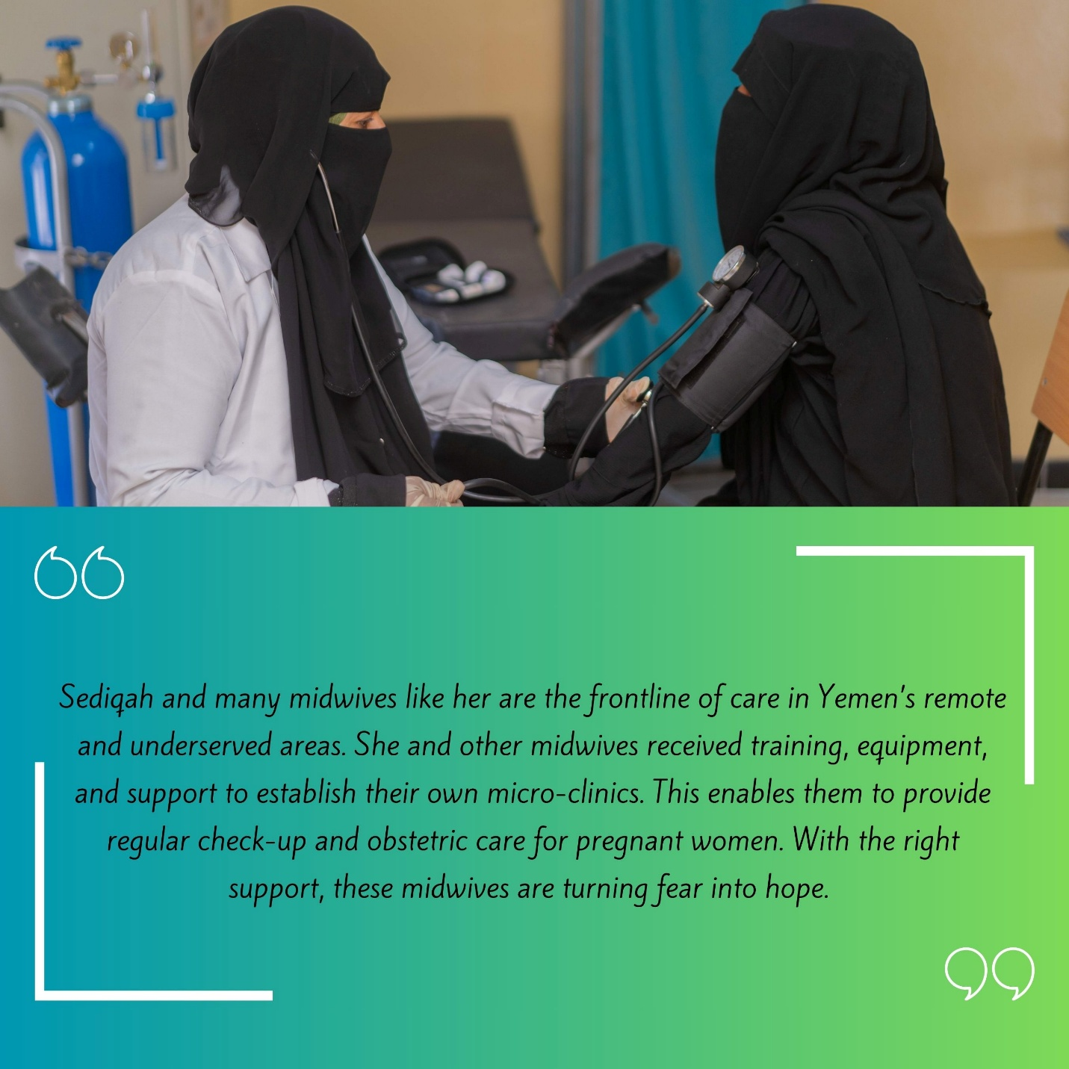

The project has also strengthened 34 food cooperatives and 33 business associations through asset transfers, institutional capacity building, and operational training, boosting their ability to aggregate production, manage risks, and scale market access. This has improved coordination across the food value chain and increased resilience to shocks. Support to the Yemen Private Sector Cluster (YPSC) contributed to unifying fragmented private sector voices through organizational capacity assessments, targeted training, and strategic studies (e.g., on e-money systems and private sector roles in recovery), further positioning the private sector as a key factor in Yemen’s economic recovery.
The outcomes of the endline surveys conducted by SMEPs within the first half of 2025 for a sample under AF indicate consistent positive impacts across all AF interventions, with significant gains in productivity, incomes, business growth, service delivery, and employment. Smallholder farmers achieved reasonable increases in production, profits, and resource efficiency; entrepreneurs, refugees, and SMEs recorded sharp growth in sales, income, formalization, and job creation; and rural clinics expanded service coverage, professionalism, and earnings. Supply chains demonstrated notable financial growth alongside environmental improvements, including waste reduction and increased use of renewable energy, while business associations strengthened institutional efficiency, expanded membership and services, and improved financial sustainability. The project’s adoption of climate-smart practices—including solar energy systems, drip irrigation, and sustainable agricultural techniques—has led to measurable environmental and productivity gains. These practices have helped reduce CO₂ emissions, conserve scarce water resources, and expand food production capacity, demonstrating the project's alignment with climate adaptation and sustainability objectives.
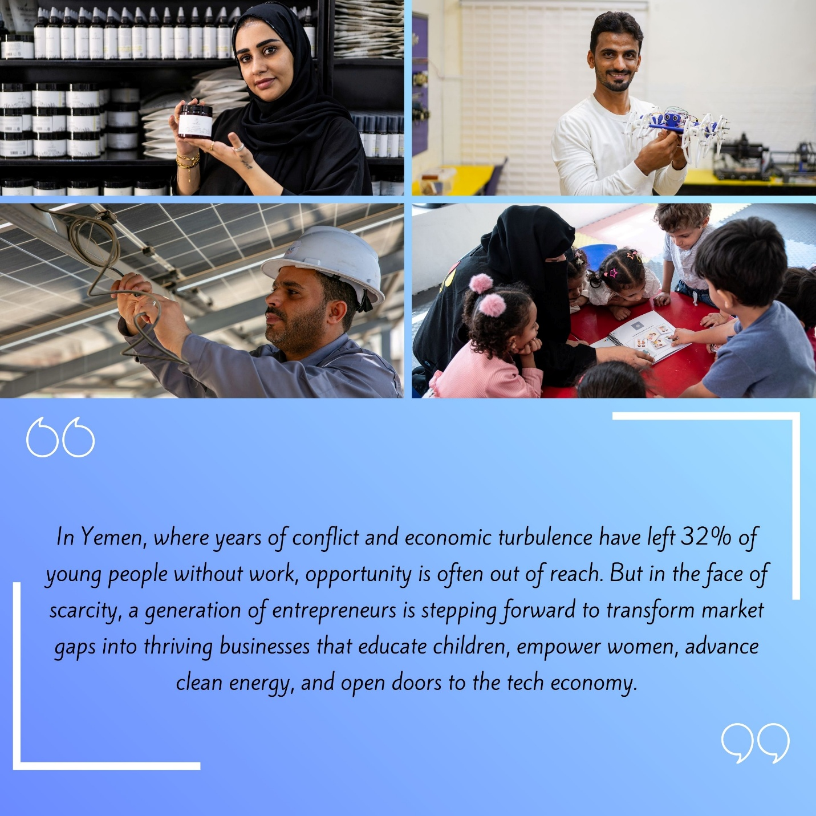
Key lessons highlight the importance of inclusive entrepreneurship support—particularly for women and youth across rural and urban areas—combined with strong public–private dialogue to create an enabling policy environment. Integrating climate-smart and renewable energy solutions, strengthening value chains through prior market assessments, and supporting women-led and innovative enterprises proved critical to boosting incomes and resilience. Flexible, pilot-based project design, geo-bundling, streamlined procurement, and targeted sectoral interventions (such as midwifery at governorate level) enhanced impact, coordination, and access to beneficiaries, while stronger engagement with universities expanded outreach to emerging entrepreneurs.
During the reporting period, SMEPS implementation faced several operational challenges, most notably the sudden suspension of activities, which affected stakeholder confidence and generated payment-related concerns among suppliers and communities. Local procurement delays persisted due to reliance on imported assets through seaports, compounded by insecurity and prolonged permit processes, particularly in northern areas, leading to delays in monitoring, equipment delivery, and impact assessments. Entrepreneurs also faced significant regulatory barriers, including high capital requirements for business registration, which delayed grant disbursements and risked loss of eligibility for some beneficiaries, while limited capacity of business incubators constrained practical support to startups. In addition, food cooperatives’ inability to mobilize required financial contributions delayed grant processing. To mitigate these challenges, SMEPS strengthened coordination with partners and authorities, promoted alternative licensing models, supported supplier capacity building, applied remote monitoring approaches, and explored more flexible beneficiary contribution and financing modalities.
Photo credit: UNDP Yemen

Component 2 Project Management, Monitoring, Evaluation and Capacity Building of National Institutions

Project Management Unit (PMU):
The Project Management Unit remains fully staffed, and UNDP continues to provide effective oversight and operational support to ESPECRP. In response to security developments affecting UN operations in Houthi-controlled areas, UNDP adjusted its operating arrangements by temporarily relocating the core project management team to the Aden sub-office, where additional investments were made to ensure continuity of project management functions.
During the reporting period, UNDP continued to assess and monitor the Entry Criteria for Access (ECA) framework agreed with the World Bank to ensure that project implementation remained compliant with fiduciary, operational, and safeguards requirements. Overall, the ECA conditions remained largely maintained across active project areas. However, the reporting period saw temporary deviations related to access and operational risks in Houthi-controlled areas, including restrictions affecting UN operations and TPM access. In line with the agreed ECA measures, implementation in these areas was paused and alternative oversight arrangements were activated, including remote monitoring, call center verification from Aden (staffed by male and female UNVs), active grievance mechanism, targeted spot checks covering documentation review and payment verification, and enhanced monitoring by implementing partners.
UNDP maintains a continued operational presence in Sana’a under adapted modalitis. The TPM remains operational in southern areas, while in northern areas—where implementation remains paused—the TPM is awaiting permits to access the limited number of subprojects approved under the agreed pause risk criteria; interim options, including engineering TPM support under FSRRP and remote verification, are being explored in consultation with the Bank.
Financial integrity safeguards remained in place, including verification of financial service providers’ AML/CFT compliance, conservative payment modalities, and strengthened financial monitoring, while sector risks such as banking disruptions continue to be monitored. Political interference remained under scrutiny and proactively prevented through transparent targeting, neutrality of implementing parntners, community engagement and proactive communication. Female participation continues to be promoted through facilitated access to project benefits and representation in VSLAs and community beneficiary committees, alongside engagement with community leaders and local authorities. Collectively, these measures support ongoing monitoring of key ECA indicators, including financial integrity, monitoring access, female participation, non-interference in partner operations, and UNDP operational access. UNDP continues to monitor these criteria closely and will adjust implementation modalities in consultation with the World Bank as conditions evolve.

The Geobundling Approach (GB):
SFD, PWP, and SMEPS in Aden meet to discuss the implementation plan for Al-Majhaf, Lahj, geo-bundling | Photo Credit: @UNDP Yemen / 2024

The geobundling approach under ESPECRP has demonstrated strong effectiveness in advancing inclusive, community-led development; however, progress during the reporting period was significantly constrained by contextual and operational disruptions. In particular, the pause of activities in Houthi-controlled areas and the suspension of SFD and SMEPS from mid-August through end-2025 affected inter-component coordination and the continuity of integrated interventions.
Anchored in the Tamkeen community mobilization model, geobundling has strengthened participatory governance through the establishment of 1,318 Village Cooperation Councils (VCCs) with near gender parity, supported by 1,566 trained local community mobilizers. These structures facilitated participatory needs assessments and village planning, leading to the formation of 119 Sub-District Development Committees (SDDCs) and the preparation of 119 Sub-District Needs Plans (SDNPs) co-endorsed with local authorities.
Based on these locally defined priorities, 97 geobundling implementation plans were developed and rolled out through coordinated action by implementing partners. While implementation progressed across most targeted sites, momentum was affected by prolonged permit issuance by local authorities, delays in environmental and social safeguard clearances, and the SFD governance crisis, in addition to the broader pause in northern areas.
Where sequencing and coordination were achieved, geobundling delivered more layered livelihood and service delivery outcomes than single-intervention models, contributing to increased employment, improved community assets, revitalized local economies, and stronger social cohesion—particularly through enhanced women’s participation in local governance. Notably, the integration of CFN with VSLA interventions established a continuum of support for mothers at risk of malnutrition by combining nutrition-sensitive cash and awareness with access to savings and sustainable income opportunities, while CFW and community assets improved access to basic services for vulnerable households.
Third-Party Monitoring (TPM) identified operational challenges, including limited beneficiary awareness and data gaps; nonetheless, early TPM data indicates positive trends in income mobility, food consumption, and social capital in areas receiving integrated support. Overall, while the geobundling theory of change remains sound, achieving consistent impact will require more proactive communication, stronger operational integration, and sustained investment in local capacity, climate resilience, and gender-responsive design.
Management Information System (MIS)
UNDP finalized and operationalized a comprehensive Geo-bundling MIS to strengthen planning, monitoring, and coordination of World Bank–funded interventions. The system consolidates data on intervention locations, subprojects, resilience plans, and partner inputs, and provides interactive mapping to support needs-based planning and operational coordination across implementing partners. The MIS also integrates remote sensing and advanced spatial analysis, including high-resolution satellite imagery, to inform site selection, hotspot identification, resilience planning, and impact evaluation. The Geo-bundling MIS resources can be accessed vial these links: (a) Yemen Geo-bundling Portal; (b) Geo-bundling Dashboard: (c) GPTA: Data Collection App; (d) SharePoint eDocument site ; (e) Power BI Interactive Report.
In parallel, the Project MIS was fully deployed to production following completion of all security and Web Application Penetration Test (WAPT) requirements. The system is now serving as a central platform for project tracking, reporting, and performance monitoring, strengthening transparency and data-driven decision-making across ESPECRP. The next focus will be placed on consolidating system adoption, enhancing functionality based on user feedback, maintaining system security and reliability, and continuing user training to maximize utilization.
ESPECRP Procurement (the procurement plan was updated in this link):
During the reporting period, procurement implementation under ESPECRP was significantly constrained by the prolonged pause in activities resulting from the SFD governance dispute since mid-August 2025, as well as security escalations affecting UN operations in Houthi-controlled areas. Procurement progress was further affected by persistent contextual challenges, including the FTO designation, heightened security and political tensions impacting banking operations and cash flow, supply chain disruptions, increased transportation costs, delayed permit issuance by local authorities in northern areas, and prolonged environmental and social safeguard clearance processes. As a result, the procurement plan required frequent adjustments to reflect evolving operational conditions.
Overall, the number of contracts planned under the three ESPECRP grants amounted to 8,453 with an estimated amount of US$ 92.7 million. Of these 5,688 contracts were completed at the amount of US$ 57.3 million. Procurement performance varied across components and financing sources. Under SFD Additional Financing (AF), disbursement reached US$24 million (91 percent) for Cash for Nutrition, US$17.128 million (87 percent) for Cash for Work, and US$1.780 million (86 percent) for VSLAs-SMED. Under AF2, disbursement stood at US$ 9.532 million (61 percent) for Cash for Nutrition, US$2.025 million (17 percent) for Cash for Work, and US$0.601 million (77 percent) for VSLAs-SMED. PWP signed 889 out of 892 Issued contracts under AF, with disbursement of US$15.72 million out of US$20.65 million allocated, and 259 of 325 contracts under AF2 with disbursement amount of US$1.94 million. SMEPS completed 789 out of 1208 contracts, achieving a 51 percent disbursement rate. UNDP signed 33 contracts with total disbursement of US$2 million out of an allocation of US$3.63 million under the original financing and AF. The geobundling impact evaluation contract with IFPRI continued implementation in southern areas, and the new Third-Party Monitoring Agency contract was finalized, with the selected firm commencing operations.
During the reporting period (July – Dec), 16 procurement-related complaints were recorded (3 from SFD, 12 from PWP, and 1 from SMEPS), primarily related to tenders awarding, consultants’ contract termination, insufficient contract duration in relation to implementation requirements, and disagreement on contract terms. 15 out of 16 complaints were addressed and resolved through verification procedures, transparent communication, and strengthened grievance redress mechanisms, contributing to improved accountability and reduced operational tensions.

Institutional Capacity Building (ICB):
During the reporting period, progress under the Institutional Capacity Building (ICB) component included the finalization of PWP’s integrated MIS and, in agreement with the WB, the commissioning of specialized legal advisory services to assess and mitigate SFD’s risks related to the FTO designation and associated sanctions. However, the pause of activities following SFD’s leadership dispute and security developments in northern areas constrained progress on several planned capacity-building initiatives, including climate change preparedness across IPs, risk management systems for PWP, and IT and data security enhancements for SMEPS.
Cumulatively, ESPECRP has thus far contributed to strengthen the institutional and operational capacities of its implementing partners – SFD, PWP, and SMEPS – through targeted training, systems development, and knowledge exchange. Key capacity-building interventions included IPSAS and fraud prevention training, IPDET certification for M&E officers, gender and occupational health and safety ToTs, and support for digital communication strategies. Capacity in Geo-enabled Monitoring (GEMS) and environmental and social safeguards was further enhanced through World Bank–led ESF trainings covering conflict sensitivity, resettlement, and PSEA.
Institution-specific support included financial management, procurement, communications, and climate-related capacity building for SFD, alongside the introduction of in-house TPM tracking systems; development of an integrated information management system and updated operational manuals for PWP, with support from UNOPS and the WB; and continued systems strengthening for SMEPS. In parallel, the World Bank facilitated extensive South–South learning under the MDTF, with exchanges on climate resilience, social protection, and value chain development, including peer learning from India, Rwanda, and the Kyrgyz Republic, as well as targeted engagements such as the SSLF in Kigali (February 2025), a gender and inclusion study tour in Cairo (June 2025), and adaptive safety nets training delivered by the IMF and ILO.
Collectively, these efforts reinforce ESPECRP’s commitment to adaptive, innovative, and locally anchored delivery systems that strengthen resilience to food insecurity and malnutrition. Looking ahead, ICB priorities will focus on climate-smart and risk-informed capacity building, aligned with the evolving priorities of the World Bank and the emerging capacity needs of the IPs. A detailed inventory of ICB activities is maintained in the updated Institutional Capacity Building tracking sheet in this link.

Monitoring and Evaluation

Third Party Monitoring (TPM)
Since the inception of ESPECRP, the Third-Party Monitoring Agent (TPMA) has verified 492 sub-projects and interviewed 12,393 direct beneficiaries (68 percent men, 32 percent women). In 2025, Apex Consultancy (TPMA) conducted comprehensive monitoring across 20 governorates, covering both northern and southern governorates. The TPMA has recently completed field visits to the sample sub-project sites for the fourth quarter of 2025, and the report is now under preparation. It is expected that the report will be available and submitted to the respective World Bank team by mid-February 2026.
During 2025, TPMA visited 199 sub-projects across all components. Findings confirm that ESPECRP is effectively meeting its objectives, reflected in high beneficiary satisfaction, improved food security, and successful community infrastructure. Positive results were particularly evident in Cash-for-Nutrition training, SME productivity, and strong community support for Community Assets (CA) and Cash-for-Work initiatives.

Key Findings from TPMA:
Cash for Nutrition (CFN)
Nearly all beneficiary mothers attended monthly sessions, with 98 percent reporting satisfaction and observing health improvements in malnourished children. Health educators confirmed positive results, referring an average of 7.4 severe acute malnutrition cases to health facilities. The findings come from 195 interviewed beneficiary mothers and 138 community health educators across 10 sub-projects.
A critical operational issue—delayed nutrition allowances to one-third of mothers in the second quarter of 2025—was fully resolved by the third quarter of 2025. However, a significant north–south disparity persists: only 31 percent of children aged 6–23 months in the north were free from food poverty compared to 70 percent in the south, largely due to higher food inflation and weaker feeding practices. These findings highlight the need for adaptive management, particularly in northern governorates.
Cash for Work (CFW)
TPM interviewed 993 direct beneficiaries and 1,031 community members across 74 sub-projects. In 2025, CFW reached 2,707 beneficiaries across 129 sub-projects, with 99 percent confirming alignment with community priorities and 97 percent expressing satisfaction. Operational performance improved markedly, including near-perfect on-time wage payments and strong safety compliance. However, wage disparities persisted—particularly affecting women—and asset sustainability emerged as a major risk, with fewer than half of sites having maintenance plans and less than 25 percent of maintenance teams receiving training.
Community Assets (CA)
TPMA verified 93 community assets sub-projects, engaging 1,130 direct beneficiaries and 1,908 community members. Satisfaction exceeded 90 percent, and on-time wage payments recovered to 97–100 percent by the third quarter of 2025. Skills acquisition was high (89–98 percent), and household wellbeing improved, particularly among northern workers. Nevertheless, sustainability remains a concern, with formal maintenance plans declining and training coverage for maintenance teams remaining below 42 percent.
Economic Opportunities and Food Market Resilience
Support to Farmer Households (SMEPS):
All 52 verified farmers reported productivity gains and adoption of modern techniques, notably drip irrigation, reducing production costs by 42–46 percent and generating local employment. Market access has emerged as the primary constraint, with nearly three-quarters citing low market prices as the main challenge, underscoring the need for stronger market linkages.
Support to Livestock Breeders:
TPM visited 20 female livestock breeders, all of whom expressed high satisfaction. Results include a 46 percent reduction in breeding costs and productivity improvements reported by 85 percent of beneficiaries.
Value Chain Participants & Business Associations:
Supported SMEs reported capital increases of 59–141 percent and profit growth often exceeding 90 percent, alongside job creation and enhanced product quality. However, market access remains a binding constraint, requiring integrated business development support.
Support to Midwives:
All six supported midwives reported expanded client bases and income increases averaging four to five times pre-intervention levels, demonstrating a highly effective model linking service delivery with entrepreneurship.
Financial Inclusion – VSLAs
243 VSLA members (51 percent women) established strong savings practices, particularly among women with no prior savings history. Women reported higher satisfaction and skill gains. Loan utilization was productive, though disparities in access for women were noted in one quarter.
Economic impact correlated strongly with group maturity, with mature groups demonstrating clearer household benefits. The programme effectively strengthened financial inclusion and social capital, with future efforts needed to ensure equitable loan access and support full maturity cycles.
Yemen Loan Guarantee (YLG)
The YLG program supported 28 loan recipients (57 percent women), with an average loan size of YER 1.65 million. Results include increased sales or production of 79 percent of beneficiaries and strong repayment capacity. High interest rates remain the principal constraint, cited by 54 percent of borrowers, indicating that while access to credit is improving, affordability remains a key challenge for sustainability.
Geo-Bundling
In 2025, geo-bundling faced operational challenges due to limited beneficiary awareness and weak data coverage. However, early evidence suggests potential for strong income mobility and improved food consumption among households receiving integrated support. Social capital impacts were consistently recognized at the community level. Overall, while the geo-bundling theory of change remains sound, its execution requires clearer communication, better targeting, and stronger operational integration to translate potential into consistent field-level impact.

Gender Mainstreaming and Gender Equality

Despite a highly constrained operating environment, ESPECRP continued to advance gender-responsive implementation across all components, with a strong focus on women’s economic empowerment, leadership, and inclusion of youth, IDPs, and people with disabilities. Under Cash for Nutrition, the project reached 141,829 women and 207,240 children and employed 4,901 women as community health educators. Women accounted for nearly one-third of beneficiaries under Cash for Work and Community Assets, participating in income-generating activities and community decision-making.

Significant progress was also achieved in women’s economic empowerment through financial inclusion interventions. Women-led MSMEs accounted for 21.4 percent of loans under the Yemen Loan Guarantee, supporting job creation and retention, while nearly half of 716 VSLA groups were women-led, reaching 8,790 women with savings, credit, and skills training. SMEPS supported 2,934 MSMEs, of which 28 percent were women-led, across multiple productive sectors.

An integrated model combining Cash for Nutrition, VSLAs, and e-wallets further strengthened women’s livelihoods and resilience, supported by microfinance institutions and emerging market linkages. In response to a SEA/SH incident and in line with World Bank requirements, SEAH prevention and mitigation measures were strengthened, including the development of an updated SEAH action plan and preparation of investigation training for IP staff.

In parallel, UNDP has initiated the revision of selected Third-Party Monitoring (TPM) questionnaires to better capture gender dynamics at the household level. This includes integrating more nuanced questions on intra-household decision-making, access to and control over resources, and differentiated impacts of project interventions on women and men. This enhancement aims to strengthen the depth and quality of gender analysis generated through TPM, and to inform more targeted and gender-responsive programming in subsequent implementation phases.

Overall, while operational constraints affected the scale of engagement during the reporting period, ESPECRP sustained meaningful progress on gender equality and inclusion. Further efforts will focus on strengthening women’s participation in community governance, enhancing gender-responsive outreach under PWP, and consolidating integrated economic empowerment approaches as implementation resumes.

Social and Environmental Risk Management

Environmental and Social Framework (ESF) implementation status
One of PWP’s engineers inspecting a construction site. | Photo Credit: @UNDP Yemen / 2024
One of PWP’s engineers inspecting a construction site. | Photo Credit: @UNDP Yemen / 2024
All the environmental and social instruments as per the Environmental and Social Commitment Plan (ESCP) have been prepared and disclosed by the project, including those for additional financing AF1 and AF2. The updated ESF tools are published and disclosed on the websites of UNDP and Implementing partners.

Environmental and Social Plans and Risk Assessments
UNDP submitted 14 Environmental and Social Action Plans (ESAP) for review and clearance during the second half of 2025. Out of 14 ESAPs the WB has already cleared six and eight are under review. This makes the total number of ESAPs 80, covering 268 subprojects for AF and AF2. The estimated cost of activities under those sub-projects is US$ 35.8 million.
For the sub-project with low-risk activities, the IPs developed Environmental and Social Risk Assessment and Clauses (ESRAAC). IPs submitted thirty seven ESRAACs during the second half of 2025. UNDP has already reviewed and cleared all ESRAACs. This makes the total number of ESRAACs cleared to 54, with the total of 128 sub-projects under AF1 and AF2.
The estimated cost of activities under those ESRAACs is US$ 16.86 million. The developed plans cover activities that are divided into four main categories: 45 percent agriculture sector, 26 percent road paving, 22 percent other WASH (Water and Sanitation) and 6 percent water harvesting.

Table 17: Status of ESAPs and ESRAAC under the ESPECRP cumulatively as of 31 Dec 2025

Category | IP | # Plans | # sub-projects | Cost in US$
ESAP | SFD | 25 | 100 | $15,720,207.00
ESAP | PWP | 55 | 168 | $20,061,357.00
ESRAAC | SFD | 39 | 78 | $11,510,862.00
ESRAAC | PWP | 15 | 50 | $5,352,203.00
ESRAAC | SMEPS | 3 | Sectors | -
Total |  | 137 | 396 | $ 52,644,629.00

Reportable Incidents:
During the reporting period, a total of 10 incidents were reported, of which 3 incidents were reported by SFD and 7 incidents reported by PWP. 2 out of the 7th PWP accidents are social accidents, one related to fighting between two workers, and Alleged SEA/SH (clarified later). All OHSthe reported accidents were minor in nature, were treated at the subproject site using First Aid Kits and did not require medical treatment except one fatility (clarified later). No environmental accidents were reported during the report period.

Table 18: Summary of incidents/accidents during the reporting period
IP | # Subprojects | Working Hours (bi-annual) | Working-Hours (Cumulative) | No of Accidents | Cumulative | % of Accidents per W.H
SFD | 31 | 994,920 | 13,958,688 | 3 | 53 | 0.1
PWP | 21 | 476,072 | 8,028,152 | 7 | 52 | 0.33

Cumulatively since 2021, a total of 107 incidents were reported across subproject sites, 53 at the SFD subproject locations, 52 at PWP project sites, and 2 in SMEPS. Of these, 3 were near misses, 87 were classified as minor, while 17 were of moderate severity. Among the 87 minor incidents, 41 took place at SFD subproject sites, 45 at PWP subproject locations, and 1 at SMEPS. Of the 17 moderate incidents, 10 occurred at SFD sites, while 7 were reported at a PWP sites, and 1 at SMEPS. Details of those incidents and accidents have been provided in the bi-annual reports. The IPs and contractors have been advised to reinforce OHS protocols, particularly in ensuring safe working positions and proper handling of equipment and tools.

Irregular Cases:
Fatality. In July 2025, a fatal incident involving one death and one serious injury occurred in proximity to an ESPECRP subproject site and was initially reported by the implementing partner as not related to project activities which stands in front of it reporting within the required timeline. Given the severity of the incident and limitations identified in the available evidence from the partner’s internal assessment as well as the escalation of the grievance to the World Bank, UNDP initiated an independent investigation in line with applicable incident response protocols.
The investigation report has been formally shared with the World Bank and is currently under review, including the incorporation of the Bank’s feedback. A dedicated discussion will be undertaken to review the findings and agree on appropriate corrective and preventive actions.
Alleged SEA/SH.On 28 August 2025, a complaint was received through the UNDP hotline under a PWP subproject concerning inappropriate WhatsApp communication between a contractor and a community member, who was also a direct project beneficiary under the subproject (later suspended due to non-compliance with safety measures).The case was initially classified as a potential SEA/SH concern in line with established safeguarding procedures.
Before UNDP could obtain the details needed to determine whether the case was credible, the complainant submitted a written withdrawal on 30 August 2025, stating that external individuals had influenced the complaint and that the allegation did not reflect the actual events. UNDP confirmed the voluntariness of this withdrawal on the same date, recorded the case in the grievance log, and considered it administratively closed at that time.
Following discussions during an Implementation Support Mission for another World Bank–funded project, the World Bank requested additional information on the case. In response, UNDP commissioned an independent third-party investigation. An initial report was subsequently shared with the World Bank; however, comments were received highlighting gaps in the analysis and compliance with SEA/SH requirements.
A revised report has been prepared, addressing all gaps identified in the previous version, and has been shared with the World Bank. The revised report strengthens the analysis in line with the ESF and the SEA/SH Good Practice Note and outlines corrective actions to improve reporting, documentation, and procedures for addressing this type of SEA/SH complaint going forward.

Grievance Mechanism (GM)
a box set up close to the construction sites in Al-Qara, Ghail Bawazir, Haddramout, to receive any complaints from the community. | Photo Credit: @UNDP Yemen / 2023
Project level
UNDP continues to operate a centralized GM call center for all World Bank–funded projects, providing beneficiaries with a safe and confidential channel to raise concerns. The call center complements grievance mechanisms established by implementing partners (IPs). Complaints received through the toll-free number are logged, analyzed, and referred to the relevant IPs for action, with UNDP following up on resolution and corrective measures. Regular coordination meetings with IPs are held to review trends, assess response quality, and identify preventive actions, including stakeholder awareness and support to affected individuals.

During the second half of 2025, a total of 1,459 grievances were recorded (362 submitted by women and 1,097 by men), of which 940 were related to SFD, 482 to PWP, and 37 to SMEPS. Cumulatively, 9,645 grievances were recorded sicne project inception (5,182 by women and 4,463 by men). The number of grievances was 3,517 in 2025 compared to 6,128 grievances in 2024, representing a 43 percent decline in volume, largely attributable to the pause in project implementation since August 2025.

Notably, the financial complaints increased significantly due to payment delays and most of the majority of these complaints could not be addressed within the two-weeks timeframe due to the suspension of the financial systems of SFD and SMEPs.

Table 19: Complaints reported by category.
Category of grievances | Number of grievances received in the reporting period (eg. Jul – Dec) |  | Number of grievances closed in the stipulated timeframe in the reporting period | Total number of grievances received since the beginning of the project |  | Number of grievances closed in the stipulated timeframe since the beginning of the project | Total number of open grievances | Number of grievances Open more than 30 days
Administrative | 17 |  | 100% | 31 |  | 100% | 0 | 0
Contractual | 157 |  | 95% | 284 |  | 97% | 0 | 0
Financial | 763 |  | 12% | 1772 |  | 47% | 210 | 210
Environment & OHS | 38 |  | 99% | 95 |  | 99% | 0 | 0
General | 40 |  | 98% | 440 |  | 97% | 0 | 0
Inclusion in selection | 326 |  | 97% | 6548 |  | 63% | 0 | 0
Social | 12 |  | 100% | 62 |  | 100% | 0 | 0
Technical | 105 |  | 95% | 394 |  | 98% | 0 | 0
Fraud | 1 |  | 100% | 19 |  | 100% | 0 | 0
TOTAL | 1459 |  |  | 9645
TOTAL | W  362 | M  1097 |  | W  5182 | M  4463
PWP (Jul-Dec) | 482 |  | PWP Total GM since the inception: 905
SFD (Jul-Dec) | 940 |  | SFD Total GM since the inception: 8691
SMEPS (Jul-Dec) | 37 |  | SMEPS Total GM since the inception: 49

A gender-disaggregated analysis of GM data reveals that women’s participation in the GM varies across the different subcomponents of the project. Under the cash for nutrition (CFN), SFD reported the largest number of women complaints (37 percent of their total complaints in the reporting period), largely reflecting the female-focused nature of CFN component and relatively effective access to grievance channels. Under SMEPS, women accounted for 14 complaints (around 38 percent of their reported complaints), indicating balanced participation despite a small caseload and suggesting that targeted engagement with women entrepreneurs supports GM accessibility. In contrast, PWP recorded no complaints from women during the same period, pointing to persistent gender-related barriers linked to the nature of public works activities, outreach approaches, and prevailing social norms.

While the suspension of SFD’s activities and payments during the reporting period caused an increase in the financial complaints by both men and women, the usual category of women’s grievances has been the inclusion in selection and administrative issues reflecting gender-specific vulnerabilities around adequate awareness of criteria and access to benefits. The low incidence of women’s complaints in technical, contractual, and OHS categories is consistent with their more limited participation in labor-intensive public works. Overall, while the GM is accessible to women under certain components, strengthened gender-responsive outreach, safer reporting channels, and women-focused monitoring indicators are needed to ensure equitable access across ESPECRP.

SEA/SH GM
SEA/SH Grievance Mechanism:
SEA/SH-related complaints are managed through the project’s existing GRM channels, including the UNDP hotline, which allows for confidential and direct reporting. During the reporting period, one complaint was received and initially classified as a potential SEA/SH case. While the case was subsequently determined not to meet the SEA/SH threshold, it highlighted important gaps in reporting, documentation, and case management procedures.
In response, UNDP has strengthened SEA/SH-related GRM procedures, including clearer internal escalation protocols, improved documentation practices, and reinforcement of confidentiality and survivor-centered principles. Verification of GRM functionality is supported through call center records and Third-Party Monitoring (TPM), including remote verification where access is constrained.
Awareness of SEA/SH reporting channels is integrated within broader community engagement and worker orientation activities; however, access remains affected by contextual constraints, including security conditions, social norms, and barriers faced by women in safely reporting sensitive complaints.
To address these gaps, UNDP has initiated targeted corrective actions, including strengthening grievance management systems, improving documentation of Code of Conduct dissemination and training, and developing a structured capacity-building plan for staff involved in grievance handling and investigations. This includes planned training (starting April 2026) on handling sensitive complaints, applying structured investigation methodologies, and ensuring alignment with the ESF and SEA/SH Good Practice Note. In addition, refresher sessions will be delivered to contractors and project personnel on professional conduct, appropriate boundaries with communities, and SEA/SH risk

Capacity Building Activities

During the reporting period, implementing partners continued safeguards training and awareness activities for staff, contractors, workers, consultants, and community committees. SFD reached over 9,700 participants with strong engagement of workers and community committees and relatively balanced gender representation. PWP trained approximately 2,400 participants, primarily workers and community committee members, though female participation remained limited outside community structures. SMEPS focused on consultants and community committees, with comparatively stronger female participation, particularly in entrepreneurship-related awareness sessions. Overall, 732 participants received GM, OHS, and environmental training, and 203 participants benefited from gender and safeguards awareness.

Table 20: Environmental and Social Risk Management Training and Awareness Raising Breakdown July -DEC 2025
Trained Parties | SFD |  |  | PWP |  |  | SMEPS
Trained Parties | M | F | Total | M | F | Total | M | F | Total
Staff | 215 | 114 | 329 | 0 | 0 | 0 | 0 | 0 | 0
Consultant Engineers and Safeguard officers | 156 | 29 | 185 | 36 | 0 | 36 | 279 | 250 | 529
Resident Engineer | 112 | 0 | 112 | 36 | 0 | 36 | 0 | 0 | 0
Workers/Direct beneficiaries | 4,612 | 3,601 | 8,213 | 2016 | 7 | 2023 | 0 | 0 | 0
Community Committees | 565 | 346 | 911 | 225 | 42 | 267 | 160 | 43 | 203
Contractors | 8 | 0 | 8 | 36 | 0 | 36 | 0 | 0 | 0

Stakeholder Engagement Plan (SEP) – Implementation Status
During the reporting period, stakeholder engagement activities were implemented across all three implementing partners, though at varying scale and intensity due to operational constraints. These consultations covered a range of topics, including subproject identification and prioritization under the geobundling approach, community needs assessments, environmental and social (E&S) risk awareness, occupational health and safety (OHS) measures, and the introduction of grievance redress mechanisms (GRM), including available feedback channels.
In addition, engagement activities incorporated awareness on SEA/SH prevention and mitigation measures, including expected standards of conduct under the Codes of Conduct (CoC), available reporting channels, and confidentiality principles. These sessions aimed to promote safe and inclusive participation, particularly for women and vulnerable groups, and to strengthen community trust in reporting mechanisms. PWP conducted 21 consultations reaching 825 participants, including 26 percent women, and established 21 community committees, though women’s representation remained limited.
SFD carried out four consultations engaging 343 participants with relatively balanced gender participation (45 percent women) and formed four community committees with 29 percent female representation. SMEPS implemented targeted coordination activities with strong female participation at the institutional level, including engagement with the Aman Association for the Blind and the Ministry of Health, supporting inclusive design and outreach to vulnerable groups.

Compared to January–June 2025, stakeholder engagement activities declined in scale during July–December, particularly for SFD and SMEPS, largely due to the suspension of activities. While PWP maintained relatively higher engagement levels, women’s participation in community committees did not increase proportionally, highlighting the need for strengthened gender-responsive outreach and partnerships with local women’s groups.

Labor Risk Management

During the reporting period, no child and forced labour were reported from the IPs, TPM, and also had been seen during UNDP sites visits. Every working site was investigated had a worker log as a formal document ensure the workers relationship to the subprojects. The workers GM in every of those sites also was settled like the GM boxes, GM posters that identify the GM channels to workers, and GM main channels nomination in the SP metal board. The effeciancy of the GM for workers can be observed through the number of complaints received and solved through the project available channels. The workers mostly were provided by drinking water, accessible toilets, and breaks for workers. The recorded workers wages were mostly according to the local market rate given into consideration the diffrentitation of the local currency rates infront of the US dollar (north and south).

There were some differentiation between the men and women wages in some interventions and this is because of the differentiation of the type of works, the rate of productivitiy, and the number of work hours. No recorded additional working hours in the sites level. Mostly the recorded workers are from the targeted areas which prevent any possibility of labour influx, community health disseases transition through external workers, no need for accommedations for workers, and in some interventions no need for toilets for workers when the interventions are with in their villages boundaries.

In the labour occupational health and safety and according to the reports and the site visits, workers are being provided by regular toolbox talk, in job training for the safely way to preform the work, the use of the work tools, permit to works, PPE, signage, emergency plans, First aid boxes,… etc. according to the site specific instruments. There were some notes on the replacing the damaged works gloves, and somes types of PPE are not suitable for the type of work they were being used for.

UNDP worked with the IPs to improve some aspects like in C4W interventions to provide coverall for those who are working with cement, study the solutions for small scale interventions that require one time use of cement safety boats which reflect a challenge in raising the PPE cost in front of the component allocations, and study solutions on the use of heavy stone and their effects to workers in SFD new stone paving methodology with out cement specially for the stones that close the boarder of the paving.

In the management system of ESRM, UNDP recommended to open signature for the branches focal points that ensure their review of the ES documents during their regular site visits. In gender enclusion, it was significant that there were participation for women in some fields but more enhancement is still required. UNDP had several meetings with the IPs studing the possible practical solutions by reviewing the potential activities where we can enhance the women opportunities specially as workers concentrating on PWP more due to the shortage in the indicators in this regard.

SEA/SH Risk Management Activities
SEA/SH risk mitigation is implemented through mandatory Codes of Conduct (CoC) and awareness activities for all workers, delivered by implementing partners through inductions and community engagement. These include information on prevention measures and reporting channels for workers, beneficiaries, and community members.

Monitoring is conducted through routine IP oversight, grievance records, and call center follow-up, complemented by UNDP field visits. Due to access constraints in northern areas, direct verification has been limited, with increased reliance on Third-Party Monitoring (TPM).

Following a recent SEAH case investigation, UNDP initiated corrective actions, including strengthened documentation, improved reporting and escalation procedures, and planned targeted training (from April 2026) for staff and contractors on SEA/SH risk handling and professional conduct. Persistent challenges include access limitations, social norms, and barriers affecting women’s participation and safe reporting. Efforts will continue to enhance gender-responsive outreach and monitoring.

Third-Party Monitoring (TPM): TPM assessed 29 sub-projects implemented by SFD and PWP, showing high overall compliance (98.2%) with environmental, social, health, and safety standards.

- Community Health and Safety: 99% compliance, with safety measures consistently in place.
- Occupational Health and Safety: 98.5% compliance; PPE usage is high, though only 85% of female workers in southern PWP sub-projects received required PPE. All workers were above 18.
- Environmental Compliance: 97.5%, with strong performance in waste management and equipment maintenance.
- Grievance Mechanism Awareness: High overall (up to 100% among female SFD workers), but lower among female PWP workers in the south (75% vs. 95% for males).
- Gender and Inclusion:
  - Significant gender wage gaps persist (men earning up to three times more in the south and 67% more in the north).
  - No childcare facilities were available, limiting women’s participation.

Conclusion:
While overall safeguards compliance is strong, targeted actions are needed to address gender wage disparities, improve women’s access to PPE and grievance mechanisms in the south, and enhance inclusion measures such as childcare support.

Communication & Visibility Plan

During the reporting period of July to December 2025, various interventions of the ESPECRP were highlighted to raise awareness among the public and key stakeholders regarding its vital role in enhancing food security resilience and sustainable recovery. By leveraging digital platforms such as X, Facebook, and Instagram, along with web-based impact stories, ESPECRP was featured through impact updates, visual stories, and in-depth narratives in both Arabic and English to ensure wider reach and relevance. As a core part of these outreach efforts, UNDP Yemen has continued to acknowledge the strategic partnership with the World Bank’s IDA and Yemen’s national institutions, including SFD, PWP, and SMEPS.
The visibility efforts during this second half of the year covered different areas and international days to communicate the ESPECRP’s impact on fostering economic recovery, food security resilience, and sustainable livelihoods.
On International Youth Day (August 12, 2025), the "Made in Yemen" campaign was launched, featuring young entrepreneurs through a series of videos and a web impact story. The campaign highlighted how young entrepreneurs, through the support of ESPECRP, are turning their passions into thriving businesses like ‘Tamz Beauty’ and ‘Solar Care,’ which directly contribute to revitalizing local economies and creating sustainable incomes.
An explainer animation on Village Savings and Loans Associations (VSLAs) was published in both Arabic and English. This know-how product illustrates how VSLAs empower community members to access community funds and start their own income-generating activities. In parallel, ESPECRP’s commitment to youth was also underscored during World Youth Skills Day, highlighting how technical assistance and skills-building are essential for the future of Yemen’s workforce.
Strengthening local food systems remained a central theme for ESPECRP. This included an impact story and a documentary video that demonstrated the project's holistic approach to food security in regions like Al-Majhafah. The messaging emphasized how integrated development approaches—connecting production to markets—are yielding integrated benefits for local populations, including improved livelihoods and sustainable agricultural practices.
ESPECRP’s vital contributions to community well-being were also featured through content highlighting access to clean water and maternal health. Visual products highlighted the rehabilitation of water schemes, which are critical for both hygiene and agricultural resilience. Furthermore, the project’s support for midwives in remote areas was also underscored, showing how empowering these frontline healthcare providers through micro-clinics continues to be a lifeline for mothers and newborns in underserved communities. These combined efforts demonstrated the multifaceted impact of this significant partnership in building a more resilient Yemen.
As of December 2025, UNDP with SFD, SMEPS, and PWP have published sixty-six videos / animations highlighting ESPECRP’s work and impact garnering over 132,531 views online. Also, 480 main social media posts have been published so far (10,517+ likes; 2,167+ shares) with 382,503+ views.

Key Actions/Activities for the Next Reporting Period (January to June 2026)

The table below summarizes the key actions that IPs and UNDP plan to complete by the end of the next reporting period in June 2026:
Subcomponent / RP | Actions
COMPONENT 2
- Cash for Nutrition | SFD will Resume CFN cash transfers and referral services activities as soon as conditions allow, with adjustments to implementation timelines if necessary.
2.2 Cash for Work / SFD | SFD will resume the implementation of the paused subprojects in the South and any approved ones in the North.  SFD will accelerate the commitment and implementation of the remaining fund with a view to closing the project.
2.3 Community Assets/ PWP | PWP will proceed with the implementation of 58 subprojects, of which 23 are community contracting.  PWP will accelerate the commitment and implementation of the remaining fund while strengthening the maintenance planning and sustainability2
2.4(a) YLG Subgrant, VSLAs, MFI Support / SFD (SMED) | SFD will create 12 new VSLAs and build the capacity of 350 new and existing VSLA members.  Support 60 current VSLA members to start or expand income-generating activities.
2.4(b)MSMEs (Farmers, Fishermen, Livestock), BAs SMEPS | SMEPs will resume the implementation of the paused subprojects in the South and any approved ones in the North and will accelerate the commitment and implementation of the remaining fund to close the project.
COMPONENT 3: Project Management, Monitoring, Evaluation and Capacity Building of National Institutions
UNDP | - UNDP will work with the IPs and the World Bank on an acceleration plan to speed up the implementation and a restructuring proposal to reflect the change of the Bank’s framework approach and the major developments faced during the period including the pauses of implementation.  - Revised the remaining allocation of the institutional capacity building (ICB) plans on emerging priorities and capacities needs.  - Finalize and share the report of the legal advisory assignment on SFD’s risk related to FTO sanction.  - Follow up with IFPRI on the progress of the GB impact evaluation in the South.  - On Communication and visibility, UNDP with IPs plan to:  - An impact story on integrated development to enhance food security resilience in Al-Majhafa, Lahj.  - A documentary video highlighting ESPECRP’s support to rehabilitating and protecting agricultural lands in Al-Mashawilah.  - A case story on the ESPECRP’s integration between the cash for nutrition and Village Savings and Loan Associations (VSLAs) to support sustainable recovery.  - UNDP will conduct two TPMA missions and will prepare for the upcoming ISM with the IPs and the WB.

Risk Framework and Risk Mitigation Measures
Systematic Operations Risk-Rating Tool
Risk Category | Rating | Update
Political and Governance | High | - Political and governance risks increased significantly during the reporting period. The U.S. re-designation of the Sana’a-based authorities as a Foreign Terrorist Organization (FTO) in March 2025 materially expanded legal, compliance, and operational constraints for activities in Houthi-controlled areas. These risks were further compounded by the detention of UN national staff and raids on UN premises since September 2025, leading to severe access restrictions, remote management arrangements, and, ultimately, a World Bank–instructed pause of disbursements in Houthi areas effective 21 October 2025. In the South, political volatility in Aden increased temporarily following tensions involving the Southern Transitional Council, though swift regional intervention prevented escalation and avoided material disruption to southern operations. UNDP continues close coordination with the UN Country Team and the World Bank, applying enhanced risk monitoring, contingency planning, and conflict-sensitive engagement to safeguard, assets, and program continuity.
Macroeconomic | High | - Macroeconomic risks remain elevated due to persistent currency shortages, liquidity constraints, and a fragmented banking system. The FTO re-designation, sanctions on Yemen Kuwait Bank (YKB), and the de-licensing of several commercial banks by CBY-Aden significantly disrupted financial flows, particularly across conflict lines. These developments increased transaction costs, delayed payments, and constrained liquidity for implementing partners. In response, UNDP diversified banking channels, shifted transactions to non-sanctioned banks, pre-positioned funds where feasible, and adjusted payment schedules to maintain delivery. SDR exchange losses continue to affect the project envelope, requiring adaptive financial planning and close coordination with the Bank to preserve implementation momentum.
Technical Design of Project or Program | Substantial | - The geobundling approach remains technically sound and strategically relevant; however, implementation complexity increased during the period mainly due to the pauses of SFD and SMEPs activities, affecting interdependent subcomponents. The implementation of impact evaluation by IFPRI in the North was affected, but continued in the South with the midline evaluation completed in November. Other delays involved in heightened clearances requirements and intensive coordination needs. Perceived imbalances in geographic allocation and sequencing have at times generated stakeholder concerns. UNDP and IPs mitigated by enhancing transparency, adjusting targeting flexibly within agreed criteria, and is coordinating with the Bank to resolve SFD’s dispute and addressing the causes that forced the pause.
Institutional Capacity for Implementation and Sustainability | Medium | - Institutional capacity risks increased moderately due to prolonged access restrictions, staff movement limitations, and governance disruptions within key implementing partners, particularly SFD. The leadership dispute within SFD constrained financial processing, supervision, and staff morale, affecting delivery in 2025. In response, UNDP paused new advances, strengthened fiduciary controls, and maintained essential oversight through third-party monitoring and remote management. Impact evaluation and monitoring activities were adapted geographically and methodologically to remain feasible. Continued investments in safeguards systems, digital tools, and decentralized implementation arrangements are supporting adaptive capacity under constrained conditions.
Fiduciary | High | - Fiduciary risks increased during the reporting period due to the convergence of banking sanctions, FTO-related compliance requirements, governance disruptions within SFD, and the pause of disbursements in Houthi areas. UNDP mitigated these risks by suspending new advances to affected partners, shifting to direct payment and reimbursement modalities, tightening liquidation cycles, and relying on vetted banking channels. Pre-pause commitments continued to be verified and settled in line with World Bank guidance. Third-party monitoring, internal controls, and enhanced financial oversight remain in place. UNDP continues to work closely with the World Bank to resolve outstanding blocked funds and ensure full compliance with fiduciary and sanctions obligations.
Environment and Social | Substantial | - Environmental and social risks remain substantial given the fragile operating context, including risks related to occupational safety, exclusion of vulnerable groups, GBV, child labor, and land disputes. While safeguards systems are well established, the clearance of E&S instruments experienced delays due to access constraints and capacity pressures, affecting implementation timelines and creating reputational risks. UNDP and the World Bank have intensified efforts to streamline clearance processes and strengthen safeguards capacity across implementing partners. TPM and field verification continue to support compliance and accountability.
Stakeholders | Substantial | - Stakeholder risks intensified, particularly in Houthi-controlled areas, due to arrests of humanitarian personnel, heightened sensitivities around engagement, and disruptions to community-level implementation. Despite these challenges, UNDP and implementing partners sustained community engagement through conflict-sensitive communication, transparency, and reliance on established local structures such as VCCs and SDDCs. In southern areas, political volatility temporarily increased uncertainty but did not materially disrupt implementation. Managing expectations and maintaining trust remain critical, requiring adaptive communication and continuous engagement with local authorities and communities.
OVERALL | High | - ESPECRP continues to operate in a highly volatile environment characterized by political instability, security incidents, banking disruptions, and governance shocks. Risks increased during the latter half of 2025 due to the FTO re-designation, detention of UN staff, leadership disputes within key partners, and pauses in disbursements. Nonetheless, the project has demonstrated resilience through timely mitigation measures, adaptive delivery modalities, and strong coordination with the World Bank and other partners. Sustained flexibility, enhanced risk management, and continued donor engagement will remain essential to protect development gains and enable recovery of implementation momentum.

ANNEXES:

Annex 1: Results Framework

PDO Level Indicators | (IPs) | Unit | Baseline | Total Targets PF+AF+AF2 | Progress as of (31 Dec 2025) | % results vs targets
Provision of Cash Transfers
Number of beneficiary households benefitting from the cash for nutrition program | SFD | Number | 0 | 106,500 | 131,178 | 123.2%
Number of beneficiary households (Social Welfare Fund) | SFD | Number | 0 | 9,300 | 8,360 | 89.9%
Number of beneficiaries (women) | SFD | Number | 0 | 111,600 | 141,829 | 127.1%
Number of beneficiaries (children) |  | Number | 0 | 153,000 | 207,406 | 135.6%
Provision of temporary employment
Number of direct beneficiaries of wage employment | SFD & PWP | Number | 0 | 155,208 | 123,391 | 79.5%
Number of beneficiaries (women-at least 20%) | SFD & PWP | Number | 0 | 33,710 | 31,262 | 92.7%
Number of beneficiaries (IDPs - at least 15%) | SFD & PWP | Number | 0 | 22,281 | 10,355 | 46.5%
Increased access to basic services and economic opportunities to vulnerable populations
Number of people with increased access to basic services | SFD & PWP | Number | 0 | 1,122,880 | 1,311,536 | 116.8%
Of which, women (at least 50%) | SFD & PWP | Number | 0 | 528,397 | 655,768 | 124.1%
Number of Micro, Small and Medium Enterprises (MSME's) supported by the Project | (SMEPS & SMED) | Number | 0 | 10,009 | 10,020 | 100.1%
Number of women-led SMEs supported by the project (at least 35%) | (SMEPS & SMED) | Number | 0 | 2,778 | 2,926 | 105.4%
People provided with access to improved sanitation services to reduce water-borne diseases exacerbated by climate change | SFD & PWP | Number | 0 | 272,845 | 114,932 | 42.1%
Intermediate Results Indicators by Subcomponents
Subcomponent 2.1: Cash Transfers (Cash for Nutrition)
Number of women beneficiaries of wage employment | SFD | Number | 0 | 3,920 | 4,902 | 125.1%
Number of indirect beneficiaries of wage employment | SFD | Number | 0 | 23,520 | 29,412 | 125.1%
Subcomponent 2.2: Labor Intensive Works and Economic Opportunities
2.1 Cash for Work (SFD)
Number of direct beneficiaries of wage employment | SFD | Number | 0 | 77,700 | 58,418 | 75.2%
Number of beneficiaries (women) (30%) | SFD | Number | 0 | 23,310 | 18,647 | 80.0%
Number of indirect beneficiaries of wage employment (family members of direct beneficiaries) (cash for work) | SFD | Number | 0 | 372,312 | 350,508 | 94.1%
Number of people with increased access to basic services | SFD | Number | 0 | 452,750 | 470,901 | 104.0%
Cubic meters of water schemes constructed/rehabilitated (Cubic Meter(m3)) | SFD | m3 | 0 | 46,066 | 41,122 | 89.3%
Area of agriculture land rehabilitated Hectare | SFD | ha | 0 | 2,477 | 4,354 | 175.8%
Length of roads improved (Kilometers) | SFD | km | 0 | 209 | 262 | 125.9%
Subcomponent 2.3: Community Assets (PWP)
Number of direct beneficiaries of wage employment | PWP | Number | 0 | 51,993 | 28,844 | 55.5%
Number of women beneficiaries (3%) | PWP | Number | 0 | 2,167 | 844 | 38.9%
Number of indirect beneficiaries of wage employment | PWP | Number | 0 | 311,958 | 195,846 | 62.8%
Number of people with increased access to basic services | PWP | Number | 0 | 670,130 | 840,635 | 125.4%
Cubic meters of water schemes constructed/rehabilitated (Cubic Meter(m3)) | PWP | Number | 0 | 147,402 | 191,204 | 129.7%
Area of agriculture land rehabilitated Hectare | PWP | Number | 0 | 5,012 | 5,676 | 113.2%
Length of roads improved (community assets) (Kilometers) | PWP | Number | 0 | 163 | 125 | 76.7%
2.4a Increased Access to finance for MSMEs (SFD/SMED)
Number of MFIs to access the new YLG portfolio guarantee scheme | SFD (SMED) | Number | 0 | 6 | 6 | 100.0%
Number of SME loans guaranteed by the new capitalization to the YLG | SFD (SMED) | Number | 0 | 3,754 | 5,353 | 142.6%
Number of Village Saving and Loans Associations | SFD (SMED) | Number | 0 | 715 | 716 | 100.1%
2.4b Direct support to MSMEs and business associations in critical sectors (SMEPS)
SMEs receiving TA and grants that produce and facilitate food distribution | SFD (SMEPS) | Number | 0 | 6,255 | 4,667 | 74.6%
Business associations supported in the target sectors directly through grants and TA | SFD (SMEPS) | Number | 0 | 50 | 67 | 134.0%
Number of new seasonal and permanent wage employment supported | SFD (SMEPS) | Number | 0 | 21,595 | 31,227 | 144.6%
Component 3: Project Management, Monitoring, Evaluation and Capacity Building of National Institutions
Surveyed beneficiaries who report receiving the right payment amount | UNDP | % | 0 | 98 | 100
Grievances received, addressed, and responded to within a timeline that has been specified and publicly communicated by the project | UNDP | % | 0 | 90 | 97
Surveyed beneficiaries who express satisfaction with project interventions (UNDP) (Percentage) | UNDP | % | 0 | 80 | 92
Capacity building action plan for SFD adopted and implemented | UNDP | Yes/No | No | Yes | In progress
Capacity building action plan for PWP adopted and implemented | UNDP | Yes/No | No | Yes | In progress

Annex 2: Annual Progress (Expenses and Direct Beneficiaries) per Subcomponent

Annual Disbursement | 2021 | 2022 | 2023 | 2024 | 2025
CFN | 2,729,294 | 10,967,321 | 11,526,193 | 10,172,943 | 6,883,971
CFW | 66,129 | 9,932,831 | 1,782,956 | 7,659,668 | 9,339,775
Community Assets | 1,069,093 | 8,619,519 | 3,402,319 | 4,259,977 | 8,432,829
YLG/VSLAs/MFIs/MSMEs | 2,529,217 | 4,177,026 | 2,148,991 | 4,017,359 | 1,462,878
Goods, works, consulting, non-consulting, Operating Costs | 4,916,050 | 8,014,521 | 9,779,543 | 9,653,024 | 11,083,062
Annual RRF | 2021 | 2022 | 2023 | 2024 | 2025
CFN | Mothers= 24036 | Mothers= 41101 | Mothers= 32096 | Mothers= 44177 | Mothers= 5,031
CFN | CHEs=484 | CHEs=1252 | CHEs=1216 | CHEs=1927 | CHEs=367
CFW | Works:  0 | Workers: 19813 | Workers: 3720 | Workers: 31618 | Workers: 15409
Community Assets | Workers: 1372 | Workers: 8931 | Workers: 3723 | Workers: 9850 | Workers: 9918
YLG/VSLAs/MFIs/MSMEs | MSMEs= 265 | MSMEs= 3399 | MSMEs= 1435 | MSMEs= 2913 | MSMEs= 2108
YLG/VSLAs/MFIs/MSMEs | VSLAs=31 | VSLAs=0 | VSLAs=223 | VSLAs=414 | VSLAs=115

Annex 3: Subcomponent Intermediary RRF by Financing Agreement, as of 31 December 2025

Subcomponent | Target | Achieved | Target | Achieved | Target | Achieved | Target | Achieved
Subcomponent 2.1 CFN Indicators | PF Targets | % PF Result | AF Targets | % AF Result | AF2 Target | % AF2 Result | Total Targets | Total Result | % Result
Number of beneficiary households benefitting | 23,000 | 181% | 38,500 | 168% | 45,000 | 55% | 106,500 | 131,178 | 123.2%
Number of beneficiaries HHs (SWF) | 2,300 | 134% | 3,850 | 92% | 3,150 | 55% | 9,300 | 8,360 | 89.9%
Number of beneficiaries (mothers) | 23,000 | 193% | 40,600 | 174% | 48,000 | 56% | 111,600 | 141,829 | 127.1%
Number of beneficiaries (children) | 27,600 | 231% | 62,400 | 167% | 63,000 | 63% | 153,000 | 207,406 | 135.6%
Number of female beneficiaries of wage employment | 920 | 118% | 1,400 | 185% | 1,600 | 76% | 3,920 | 4,902 | 125.1%
Number of indirect beneficiaries of wage employment | 5,520 | 118% | 8,400 | 185% | 9,600 | 76% | 23,520 | 29,412 | 125.1%
Subcomponent 2.2 CFW Intermediary indicator | PF Targets | % PF Result | AF Targets | % AF Result | AF2 Target | % AF2 Result | Total Targets | Total Result | % Result
Number of direct beneficiaries of wage employment | 21,500 | 98% | 38,000 | 79% | 18,200 | 40% | 77,700 | 58,418 | 75.2%
Number of women benefit. (30%) | 6,450 | 102% | 11,400 | 77% | 5,460 | 61% | 23,310 | 18,647 | 80.0%
Number of indirect beneficiaries of wage employment | 129,000 | 98% | 165,312 | 109% | 78,000 | 56% | 372,312 | 350,508 | 94.1%
Number of people with increased access to basic services | 138,500 | 214% | 220,000 | 69% | 94,250 | 24% | 452,750 | 470,901 | 104.0%
Cubic meters of water schemes constructed/rehabilitated (m3) | 20,746 | 37% | 18,300 | 182% | 7,020 | 3% | 46,066 | 41,122 | 89.3%
Area of agriculture land rehabilitated Hectare | 879 | 49% | 1,000 | 335% | 598 | 95% | 2,477 | 4,354 | 175.8%
Length of roads improved (km) | 45 | 195% | 92 | 177% | 72 | 16% | 209 | 262 | 125.9%
Subcomponent 2.3 CA Intermediary indicator | PF Targets | % PF Result | AF Targets | % AF Result | AF2 Target | % AF2 Result | Total Targets | Total Result | % Result
Number of direct beneficiaries of wage employment | 16,940 | 76% | 25,173 | 57% | 9,880 | 15% | 51,993 | 28,844 | 55.5%
Number of female benefit (3%) | 508 | 113% | 1,259 | 21% | 400 | 2% | 2,167 | 844 | 38.9%
Number of indirect beneficiaries of wage employment | 101,640 | 88% | 151,038 | 67% | 59,280 | 8% | 311,958 | 195,846 | 62.8%
Number of people with increased access to basic services | 255,000 | 177% | 291,330 | 130% | 123,800 | 9% | 670,130 | 840,635 | 125.4%
Cubic meters of water schemes constructed/rehabilitated (m3) | 57,000 | 115% | 63,042 | 198% | 27,360 | 3% | 147,402 | 191,204 | 129.7%
Hectare of Agri land rehabilitated | 1,600 | 160% | 2,522 | 124% | 890 | 0% | 5,012 | 5,676 | 113.2%
Length of roads improved (km) | 38 | 128% | 66 | 108% | 59 | 9% | 163 | 125 | 76.7%
Subcomponent 2.4 MSMEs Intermediary indicator | PF Targets | % PF Result | AF Targets | % AF Result | AF2 Target | % AF2 Result | Total Targets | Total Result | % Result
Number of MFIs to access the new YLG portfolio guarantee scheme | 3 | 100% | 2 | 100% | 1 | 100% | 6 | 6 | 100.0%
Number of SME loans guaranteed by the new capitalization to the YLG | 3,024 | 105% | 0 | 0% | 730 | 297% | 3,754 | 5353 | 142.6%
Number of VSLAs | 30 | 150% | 500 | 100% | 185 | 92% | 715 | 716 | 100.1%
SMEs receiving TA and grants that produce and facilitate food distrib. | 1,630 | 103% | 3,200 | 37% | 1,425 | 10% | 6,255 | 4,667 | 74.6%
Business associations supported through grants and TA | 20 | 100% | 30 | 157% | - | 0% | 50 | 67 | 134.0%
Number of new seasonal & permanent wage employment | 8,320 | 175% | 9,600 | 47% | 3,675 | 6% | 21,595 | 31,227 | 144.6%

Annex 4: Communication and Visibility Reference Links

All visibility videos can be accessed from this link: https://www.dropbox.com/sh/7mwhellqnhnf8l2/AAAIyGxf-EolOf3aiBGWfKLRa?dl=0

Title | Links
Access to Water | X  Arabic: https://x.com/UNDPYemen/status/1984634411719987319?s=20  English: https://x.com/UNDPYemen/status/1984592263939285434?s=20
Made in Yemen (#InternationalYouthDay campaign) | Web impact story  Arabic: https://undpyemen.exposure.co/made-in-yemen-ar?source=share-UNDPYemen  English: https://undpyemen.exposure.co/made-in-yemen?source=share-UNDPYemen  X  Arabic: https://x.com/UNDPYemen/status/1955354140047208568?s=20  English: https://x.com/UNDPYemen/status/1955336821388271721?s=20  Dorri’s video  Arabic: https://x.com/UNDPYemen/status/1956012295911362932?s=20  English: https://x.com/UNDPYemen/status/1955975339940659591?s=20  Solar Care video  Arabic: https://x.com/UNDPYemen/status/1957495207408361916?s=20  English: https://x.com/UNDPYemen/status/1957480108505158107?s=20  Mr. Robot video  Arabic: https://x.com/UNDPYemen/status/1976362094401294577?s=20  English: https://x.com/UNDPYemen/status/1976346927013953674?s=20  Tamz Beauty  Arabic: https://x.com/UNDPYemen/status/1977811577324925025?s=20  English: https://x.com/UNDPYemen/status/1977796476702183592?s=20
Support to Midwives | X  Arabic: https://x.com/UNDPYemen/status/1947630843830108302?s=20  English: https://x.com/UNDPYemen/status/1947585054365925768?s=20
Explainer Animation on VSLA | X  Arabic: https://x.com/UNDPYemen/status/1982145134117400938?s=20  English: https://x.com/UNDPYemen/status/1982130033251566077?s=20
Strengthening Local Food Systems | Web impact story  Arabic: https://undpyemen.exposure.co/strengthening-local-systems-for-sustainable-food-security-in-yemen-ar  English: https://undpyemen.exposure.co/strengthening-local-systems-for-sustainable-food-security-in-yemen  Video  Teaser  X  Arabic: https://x.com/UNDPYemen/status/1944456794094366924?s=20  English: https://x.com/UNDPYemen/status/1944441700136734896?s=20  Main video  YouTube: https://www.youtube.com/watch?v=L_Xep2cgnEw  X  Arabic: https://x.com/UNDPYemen/status/1945124847408795863?s=20  English: https://x.com/UNDPYemen/status/1945088560081854629?s=20  X  Arabic: https://x.com/UNDPYemen/status/1943382717359370421?s=20  English: https://x.com/UNDPYemen/status/1943359379664711756?s=20
Other | https://x.com/UNDPArabStates/status/1957498730393063656?s=20  https://x.com/UNDPArabic/status/1950592222015246568?s=20  https://x.com/UNDPArabStates/status/1950608077322871059?s=20  https://x.com/UNDPYemen/status/1946630225342636341?s=20  https://x.com/UNDPYemen/status/1946645545956647423?s=20  https://x.com/UNDPYemen/status/1979262773960884525?s=20  https://x.com/UNDPYemen/status/1979291987082907939?s=20

Annex 5: Screening tool for active sub-projects in Houthi controlled areas

ESPECRP: Screening tool for active PWP sub-projects in Houthi controlled areas
Risk Dimension | Key Screening Question | Low | Moderate | High
Environmental Risk | Would stopping works cause environmental harm (erosion, flooding, pollution, etc.)? | No environmental harm; impacts fully reverseable | Some localized or temporary impacts | High likelihood of serious or irreversible harm (flooding, erosion, habitat damage)
Community Healht & Safety | Would pausing create hazards for the public (open excavations, unstable structures, blocked roads)? | No exposed hazards | Managable hazards with controls | Immediate or severe risk to life, health, or safety
Safety and Security (Staff/Contractors) | Are workers exposed to safety or security threats if works stop or continue? | No significant risks | Some risks requiring mitigation | High risk of injury, violence, or insecurity
Critical Services & Access | Would stopping disrupt water, sanitation, roads, health access, or community access/travel? | No disruption | Partial or short-term disruption; managable with mitigation | Significant risk of disruption to essential services or access
Social & Reputational Risk | Could stopping trigger community tensions, disputes, or reputational damage? | No expected tensions | Localized or managable disputes | High tension/conflict risk, loss of trust, reputational harm
Financial & Legal Risk | Are there liabilities if the contract is paused or terminated | Minimal or no cost | Moderate claims or delays | Significant compensation, penalities, or legal exposure
Additional considerations based upon the Entry Criteria for Access (Yes/No)
TPM Access | Can the TPM access the location? | Yes - Eligible to be considered |  | No - Ineligible to be considered
PWP Access | Can PWP acess and operate in the area free of impediment? | Yes - Eligible to be considered |  | No - Ineligible to be considered
Interference Risk | Is there any concens of interference by local authorities? | No - Eligible to be considered |  | Yes - Ineligible to be considered

Annex 5 provides the screening tool used to classify the active subprojects in Houthi Control Areas.
This indicator includes direct workers from all subcomponents (CFW, CFN, Community Assets and the additional jobs created by MSMEs)
The relatively lower number of IDPs reflects the geograhic targeting under geobunding focusing on food insecurity and malnutrition regardless of the number of IDPs. UNDP and IPs will explore ways to address this shortcoming.
This target comprises the number of MSMEs targeted by SMEPS, SMED and Yemen Loan Guarantee (YLG).
Sanitation interventions were fewer due to community prioritization under the geobundling approach, which favored investments in water harvesting, agriculture, and roads. This will be reviewed with the implementing partners and the World Bank under the proposed restructuring.
The total grant amounts in USD have been impacted by fluctuations in the SDR exchange rate, resulting in estimated losses as of the end of June 2025 of approximately $1.48 million under PF and around $4.5 million under AF. These gaps are proportionately reflected in the activity lines of the subcomponents under Component 2. The committed activities under PF were carried over to AF, while the activities under AF will be reviewed and decided upon at a later stage.
The bank interest generated under PF amounted to $376,551.49 which has been reported in the relevant Interim Financial Report (IFR). Under AF, the interest accrued is $52,247.38, which is planned to be used to pilot the e-wallet initiative with CFN. No further bank interest has been generated since March 2023, following the Houthi’s decree banning bank interest.
While overall delivery remains strong, progress was affected by delays linked to the major events outlined in this report. The CfW and PWP subcomponents experienced slower implementation due to the time required earlier to ensure complementarity under the geobundling approach and, subsequently, for environmental and social safeguard preparation and clearance processes.
The original PF amount was decreased by $1.48 Million due to SDR vs USD exchange rate loss.
The remaining balance ($0.31M) is under UNDP Management and will be requested totally in 2026 for final evaluation.
Around $10K bank interest is left under PF, which was agreed to support geobundling under AF and will be fully cleared next period.
CFW Diversified interventions comprise different types of relatively small activities prioritized by a community to engage as many people as possible in need within the available allocation in that target community. These may encompass a couple or more activities including home gardens, small water schemes, shelters, vocational training for women, small-lane pavement, among others.
Around US$ 500 per household involved in CFW wage employment over an average period of 4 months.
By financing source: Under PF, all 150 subprojects were completed (US$12.1 million); under AF, 172 subprojects were identified (US$18.04 million), with 159 contracted, 125 completed (US$12.34 million), and 34 ongoing (US$3.46 million); and under AF2, 68 subprojects were identified (US$8.75 million), with 32 contracted, 7 completed (US$0.5 million), and 24 ongoing/paused (US$3.37 million).
The target is expected to be lowered by around 15% due to the use the budget line to offset operation deficit and SDR loss under AF and PF. The adjustment is reflected in the restructuring proposal submitted 11 March to the Bank
A link to the list of the approved subprojects based on the agreed classification criteria: https://docs.google.com/spreadsheets/d/12jTljyeSIajF0JJblbYF0m8nNQsCGRQc/edit?usp=sharing&ouid=111114374262268935071&rtpof=true&sd=true
Earlier under the PF, SFD provided grants $38,000 to Azal and Hadhramout MFIs to enhance IT systems, resulting in modern data centers that improved security, efficiency, and all-day service accessibility, supporting digital financial inclusion.
A Village Savings and Loan Association is a group of around 25 individuals from a village who save amounts of money together in regular meetings and obtain small loans from these savings whenever there is sufficient money to start or expand their income-generating activities.
Aden; Amran; Abyan; Al Bayda; Al Dhale'e; Al Hudaydah; Al Jawf; Al Mahrah; Al Mahwit; Amanat Al Asimah; Dhamar; Hadramaut; Hajjah; Ibb; Lahij; Ma'rib; Raymah; Shabwah; Socotra; and Ta'izz.
https://docs.google.com/document/d/1xAt15LAjvRRGpEGQUW-hCEZtjDBGkPP_/edit?usp=sharing&ouid=111114374262268935071&rtpof=true&sd=true
https://www.undp.org/yemen/projects/emergency-social-protection-enhancement-and-covid-19-response-project-especrp

